NOTICE INVITING PROPOSALS
FOR
UPDATING AND EXPANSION OF PARKING LOT VIDEO CAMERA SURVEILLANCE
AT THE IMPERIAL COMMUNITY COLLEGE DISTRICT

RFP # 1003

The Board of Trustees of Imperial Community College District requests the submission of formal proposals for updating and expansion of parking lot video camera surveillance in accordance with the attached specifications.

A detailed explanation of our Request for Proposal and facts about Imperial Community College District can be obtained on the college’s website (www.imperial.edu/RFP).
Pay particular attention to sections A & B that specifies mandatory compatibility issues and explains installation locations that need to be considered in your response.

All sealed proposals shall be received up to but no later than 2 p.m. Thursday December 10, 2015 at Imperial Valley College, Purchasing Department, 380 East Aten Road, Imperial, CA 92251.

In accordance with provisions of California Business and Professions Code Section 7028.15 and Public Contract Code Section 3300, the DISTRICT requires that the bidder possess applicable classification (s) of contractor’s license(s) at the time the bid is submitted. Any bidder not so license at the time of the bid opening will be rejected as non-responsive.

As required by Section 1773 of the California Labor Code, the California Department of Industrial Relations has determined the general prevailing rates of per diem wages in the locality in which the work is to be performed. Copies of these wage are determinations, entitled PREVALILING WAGE SCALE, are maintained at:

Department of Industrial Relations,
Division of Labor Statistics and Research
455 Golden Gate Avenue 8th Floor,
P O Box 420603,
San Francisco, CA 94102-0603
415-703-4774
www.dir.ca.gov/dlsr/pwd

The successful bidder upon award of the contract shall post a copy of this document at each work site. It shall be mandatory upon the successful bidder to whom the contract is awarded, and upon any subcontractor listed, to pay not less than the specified rates to all workers employed by them for the Project.

LATE PROPOSALS WILL NOT BE ACCEPTED

Each proposal shall specify completely each and every item as set forth in the specifications. Any and all exceptions to the original specifications must be clearly stated in the proposal and the failure to do so may be grounds for rejection of the proposal.

The Board of Trustees has the right to select the proposal which best meets the needs of the District and enter into contract(s) incorporating the proposal(s) as submitted. The Board reserves the right to reject any or all proposals or waive any irregularities in the submission process.

All questions should be emailed to: sergio.lopez@imperial.edu

Respectfully,

Sergio A. Lopez,
Interim Vice President for Student Services

REQUEST FOR PROPOSALS
RFP # 1003
UPDATING AND EXPANSION OF PARKING LOT VIDEO CAMERA SURVEILLANCE
IMPERIAL COMMUNITY COLLEGE DISTRICT

1. General Information

The Imperial Community College District is updating and also expanding its video camera surveillance system for all parking lot areas within the campus.

This project will replace cameras and wireless transmitters in some locations where wireless video cameras are currently located but require new wireless transmissions sent from that location to a receiving location on top of the Gymnasium Building 700.

2. Scope of Services

A. Hardware and associated items.
a. All hardware including Cameras, radio transmitters, etc. must be compatible with the monitoring / viewing station software version 5.5.38.4 as provided by Video Insight Inc., 3 Riverway, Suite 700, Houston, TX 77056

b. All video cameras will be able to record images during both daylight and nightlight conditions.

c. All video cameras must have suitable resolution to read a license plate at 200 feet and have an approximately 30 foot wide field of view at the 200 foot distance.

d. Two locations will require solar power to provide all electrical needs of multiple cameras and wireless radio transmitter. These solar locations will require enough battery backup to provide for at least 18 hours of operation during times of darkness while recharging within an 8 hour period of daylight. With the camera pole being set into an unimproved dirt area.

e. Camera locations that require wireless transmissions will also require a receiver placed on top of the Gymnasium Building 700. An antenna is already in place to mount the necessary receivers however vendor is required to make necessary connections to the already established data connections.

f. Three locations are new installations which will require video cameras to be installed on top of three separate buildings; 2700, 3200, and 700. We are requesting separate price quotes for these 2 items;
1. Wireless transmissions from the video cameras attached to the buildings and sent to the top of building 700 where an antenna is already in place to have the receiving radio receivers attached and then connected to cabling which is already in place.
2. Installing the cameras on the buildings and only connecting all cameras to a College provided data cable located adjacent to the camera locations.

g. Two locations will require the installation of wireless video cameras whose transmissions are sent to a receiving location on top of the Gymnasium Building 700. Where the camera pole and electricity are already in place.

h. Two locations will require the installation of wireless video cameras and poles whose transmissions are sent to a receiving location on top of the Gymnasium Building 700. With the video camera pole being set onto an existing concrete pad which already has a dedicated 115 volt line in place.

i. One location will require replacement of video cameras only with the pole, power, and data connections already in place.

B. Installation of the above listed hardware items in the following locations. Installed as specified in the following locations.

1. Gymnasium 700 Building with 3 cameras;
a. 3 each recommended box cameras, 2 on west side of Gym and 1 on East side of Gym, focused on Parking Lot D.
1. Dedicated 115 volts provided by College at this location.
2. Wall mounts, cameras, and video connection provided by contractor

2. Drive One with three cameras;
a. 3 video cameras, solar panels, rechargeable battery, and one transmitter from MicroPower "SOLVIEL" or other recommended source, and one camera pole.
1. One camera focused to the South on Drive One and 2 cameras focused to the East on Parking Lot C
2. All cameras, solar panels, batteries, transmitters, camera pole, and installation of camera pole into unimproved dirt provided by contractor.

3. Parking Lot C with 3 cameras;
a. 3 each recommended box cameras, 2 focused to the West on Parking Lot C and 1 focused to the East on Parking Lot B.
1. Dedicated 115 volts provided by College at this location.
2. All cameras, transmitters, camera pole, and installation of camera pole into a concrete slab provided by contractor.
4. Parking Lot A (West side) with 4 cameras;
a. 4 each recommended box cameras, 1 focused to the South on Drive Two, 1 focused to the West on Parking Lot B, and 2 focused to the East on Parking Lot A
1. Dedicated 115 volts provided by College at this location.
2. All cameras, transmitters, camera pole, and installation of camera pole into concrete slab provided by contractor.

5. Parking Lot A (East side) with 3 cameras;
a. 3 video cameras, solar panels, rechargeable battery, and one transmitter from MicroPower "SOL VIEL" or other recommended source, and one pole.
1. 2 cameras focused to the West on Parking Lot A and 1 camera focused to the West on Parking Lot N.
2. All cameras, solar panels, batteries, transmitters, camera pole, and installation of camera pole into unimproved dirt provided by contractor.

6. Parking Lot L with 2 cameras;
a. 2 each recommended box cameras, 1 focused to the East on Drive Three, 1 focused to the West on Parking Lot L.
1. Dedicated 115 volts, video connections, and pole provided by College at this location.
2. Cameras and installation provided by contractor.

7. 2700 Building with 4 cameras;
a. 2 each recommended box cameras mounted on the east side of Building 2700 focused to the East on Parking Lot K and 2 each 4MP box cameras mounted on the West side of Building 2700 focused to the North on Parking Lot I.
1. Dedicated 115 volts provided by College at this location.
2. Wall mounts, cameras, and video connection provided by contractor.

8. Parking Lot J with 4 cameras;
a. One recommended camera focused to the East on Drive Three and 3 recommended cameras focused to the South on Parking Lots I-J - K.
1. Dedicated 115 volts and pole provided by College at this location.
2. Cameras, transmitter, and installation provided by contractor.

9. Parking Lot H with 3 cameras;
a. 3 recommended cameras focused to the South on Parking Lots H - I- J.
1. Dedicated 115 volts and pole provided by College at this location.
2. Cameras, transmitter, and installation provided by contractor.

10. 3200 Building with 3 cameras;
a. 3 each recommended box cameras (2 on South side of Building focused on Parking Lot H and 1 on North side of Building focused on Parking Lot H.
1. Dedicated 115 volts provided by College at this location.
2. Wall mounts, cameras, and video connection provided by contractor.

(Continued on page 6)

C. Campus Map identifying the 10 camera locations.
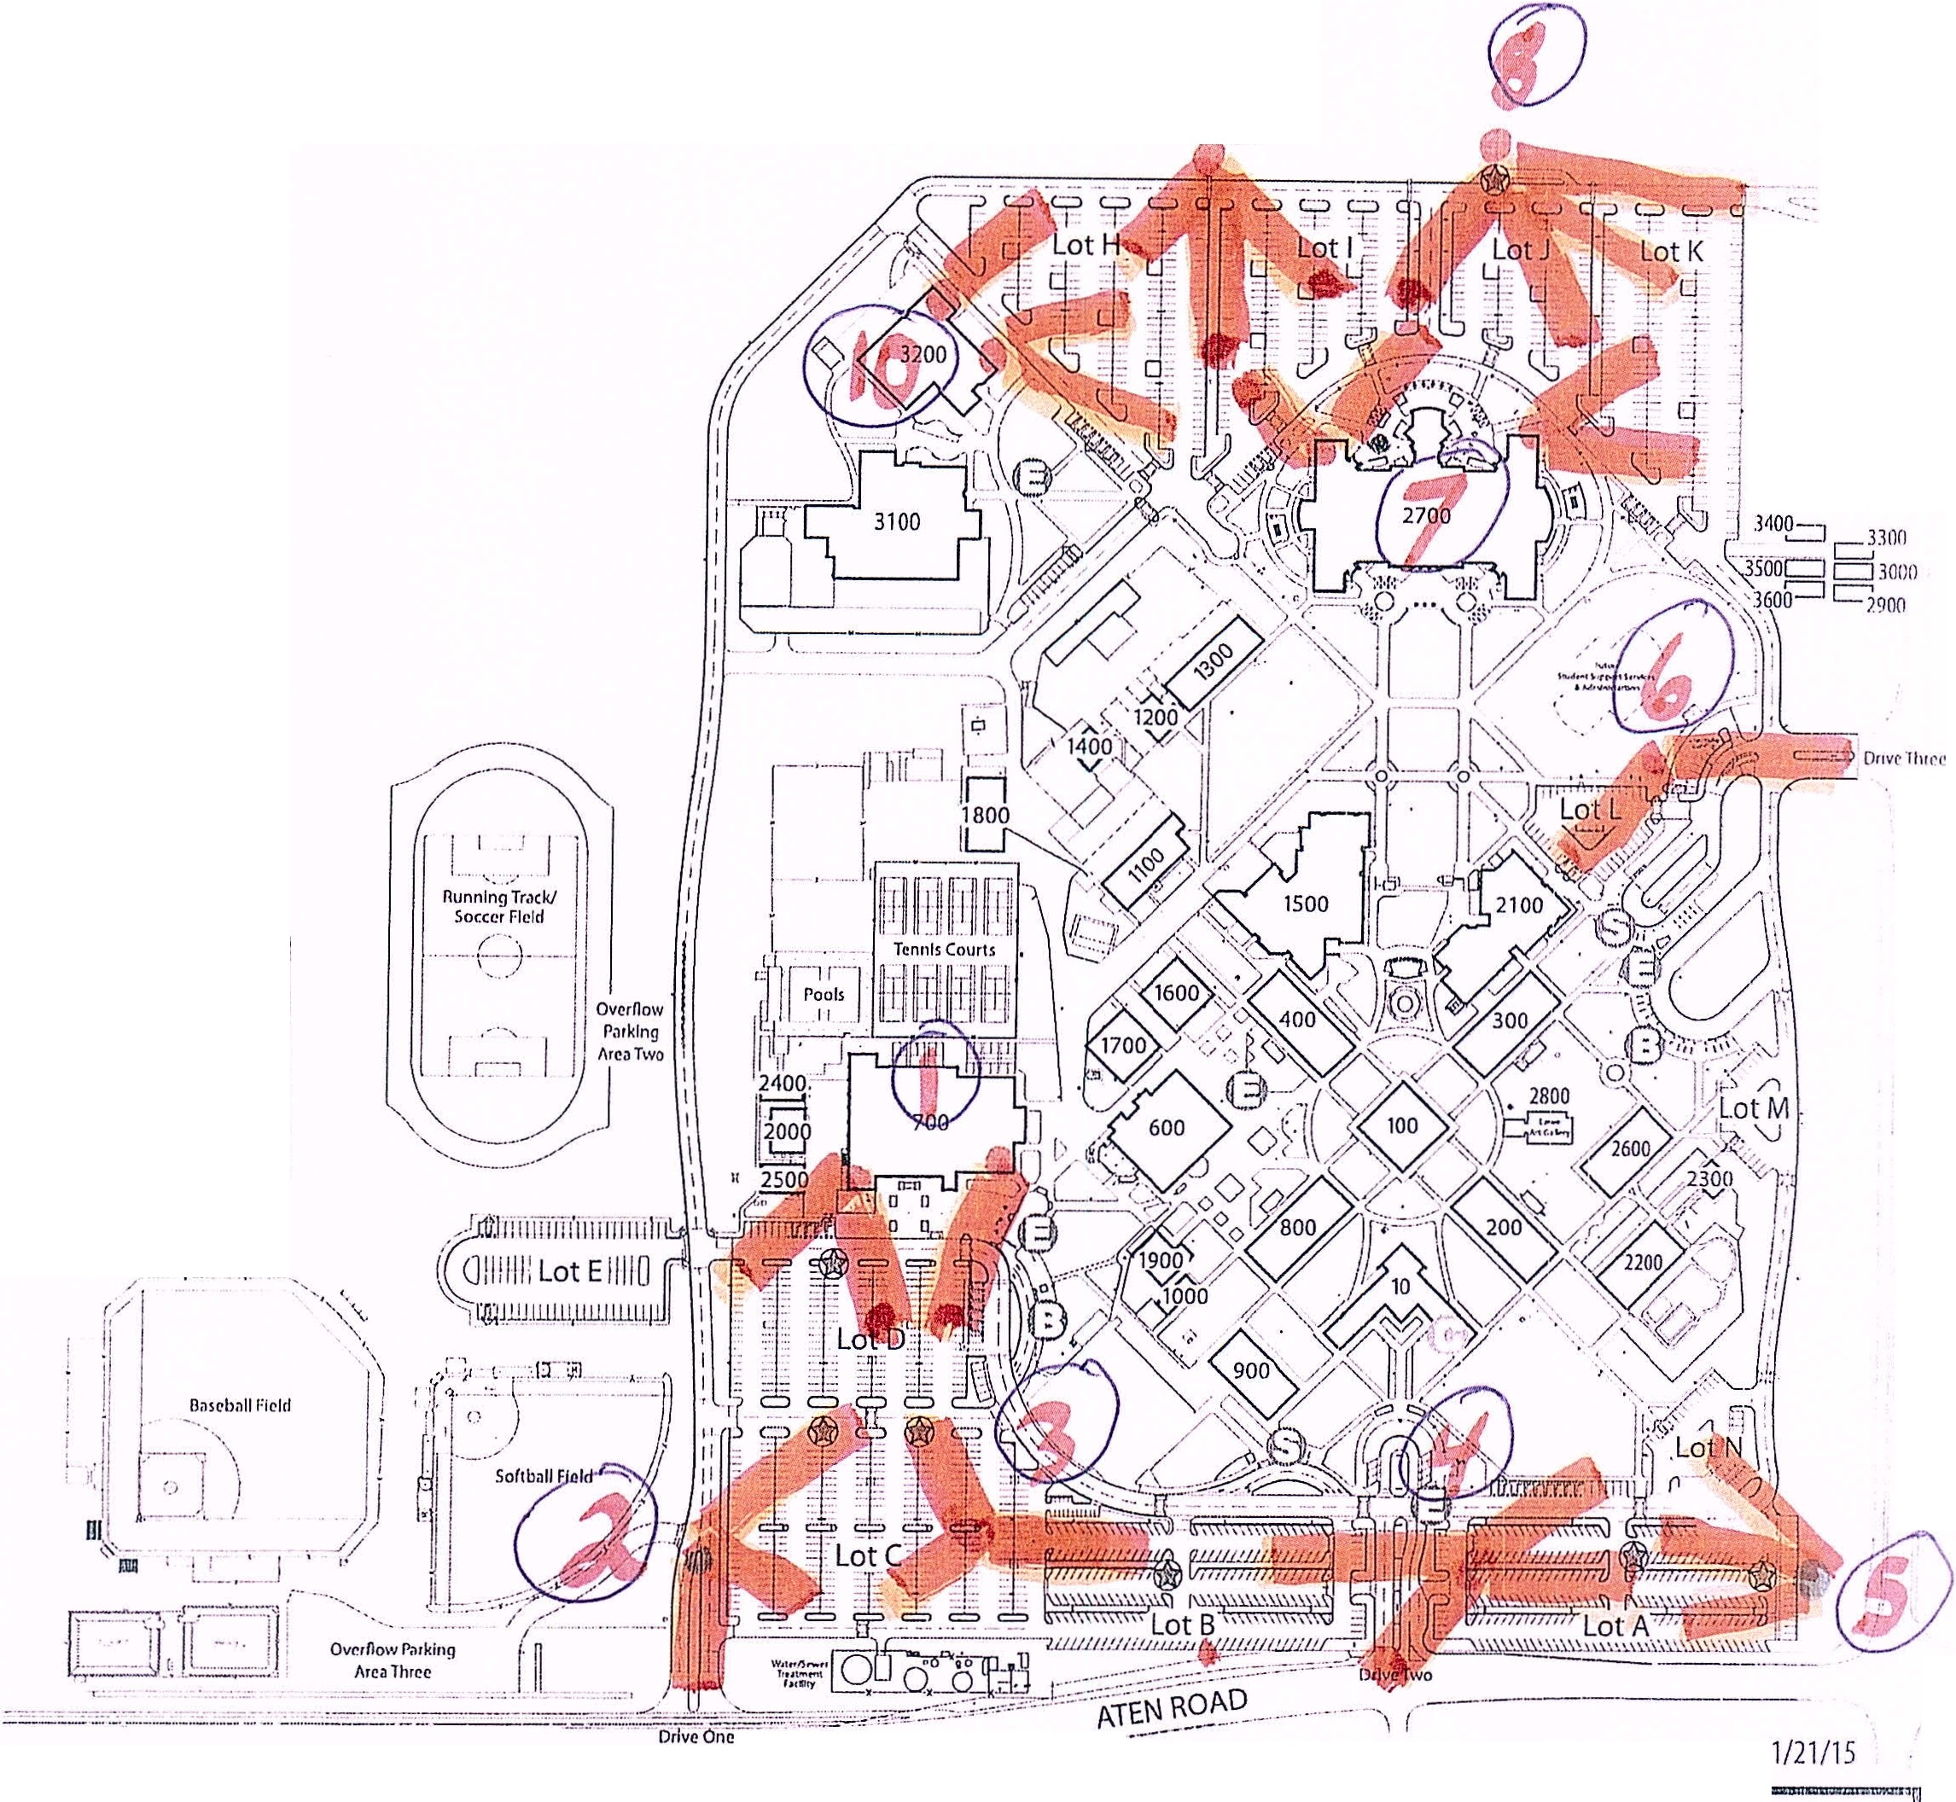

- Site Inspection, Evaluation, and Selection Process

  - A site inspection shall be held on Thursday December 3, 2015 at 12pm. The location of the site inspection is 380 East Aten Road, Imperial, California 92251. This will be an opportunity to tour the campus and inspect the various locations where the work is to be completed, the camera poles are to be placed, and the receiving location for the wireless signals. Additionally the District’s IT Staff will be present to discuss the required connection of the wireless signal to the District’s data cables.

  - All completed proposals shall be received by the District by 2:00 p.m. on Thursday December 10, 2015.

  - Following receipt of the proposals they will be reviewed for completeness.

  - All decisions made by the District are final and not open to arbitration.

6. District Contact Person

Sergio A. Lopez, Interim Vice President for Student Services
Email address: sergio.lopez@imperial.edu
Phone number: (760) 355-6456.

