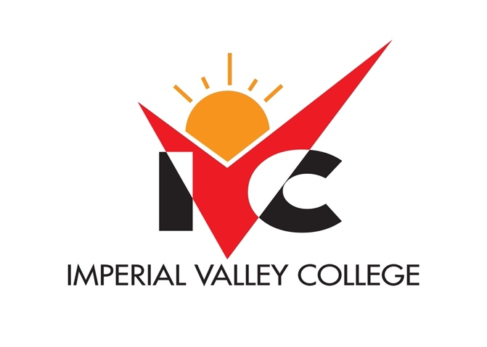
Governance Handbook
Draft 10.29.21

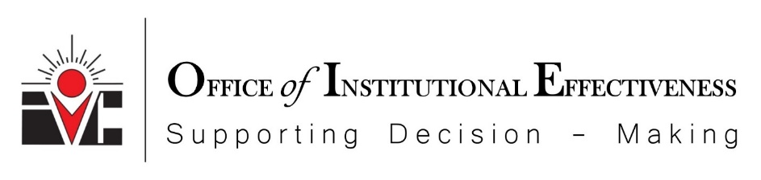

SECTION 1
INSTITUTIONAL MISSION, VISION, AND VALUES
Mission, Vision, and Values Planning
In 2020, Imperial Valley College introduced it’s 2021-2030 Vision Comprehensive Master Plan. (CMP). A culmination of about one year of research and preparation, the new plan sets a pathway for the College. The CMP provides a roadmap during the next nine years. The Comprehensive Maser Plan incorporates the Vision, Mision, and Values. The CMP has incentivized changes to the current mission, vision, and values. The college is preparing to embark on making updates by engaging campus-wide constituents led by the newly established participatory governance structure and Integrated Consultation Council (ICC).

In the fall of 2020, a Stakeholder’s Questionnaire was issued across campus. More than 257 participants provided their feedback and the results of the survey will guide the development and implementation of the College’s Mission, Vision, and Values.

A communication email was sent campus-wide on Thursday, November 19, 2021. Please refer to Appendix A for the communication email.

IVC’s Mission, Vision, and Values

Imperial Valley College’s Current Mission Statement:
The mission of Imperial Valley College is to foster excellence in education that challenges students of every background to develop their intellect, character, and abilities; to assist students in achieving their educational and career goals; and to be responsive to the greater community.

Imperial Valley College’s Current Vision Statement:
To provide quality education that enriches lives and builds futures.

Imperial Valley College’s Current Values Statement:
As a student-centered organization, we will uphold the following core values:
Excellence: Providing superior service and educational learning opportunities that provide, promote and enhance student learning and growth.
Integrity: Guiding the college's actions with an internally consistent framework of principles that demonstrate forthright, honest and ethical behavior in all interactions.
Accessibility: Building and creating an inclusive and accessible learning environment which provides equitable treatment for all, without discrimination.
Diversity: Recognizing and valuing the strengths of our diverse backgrounds and perspectives in an environment that respects diverse traditions, heritages, and experiences.
Collaboration: Encouraging recursive interaction of knowledge, experience and mutual learning of people who are working together toward a common creative goal.
Innovation: Providing innovative approaches to learning, problem-solving and growth in response to a rapidly changing environment.
Fiscal Integrity: Ensuring the fiscal integrity of the District to fulfill its mission.
The District's values provide the guidance and inspiration for implementing and maintaining programs to promote student success.
SECTION 2
BP 2510 PARTICIPATION IN LOCAL DECISION-MAKING & GOVERNANCE STRUCTURE
IMPERIAL COMMUNITY COLLEGE DISTRICT
BP 2510

Participation in Local Decision-Making
Reference: Education Code Section 70902(b)(7); Title 5, Sections 53200 et seq., (Academic Senate), 51023.5 (Staff), 51023.7(Students) Accreditation Standard IV.A and IV.D.7

The Board is the ultimate decision-maker in those areas assigned to it by state and federal laws and regulations. In executing that responsibility, the Board is committed to its obligation to ensure that appropriate members of the District participate in developing recommended policies for Board action and administrative procedures for CEO action under which the District is governed and administered. Each of the following shall participate as required by law in the decision-making processes of the District:

Academic Senate(s) (Title 5, Sections 53200-53206.)
The Board or its designees will consult collegially with the Academic Senate, as duly constituted with respect to academic and professional matters, as defined by law. Procedures to implement this section are developed collegially with the Academic Senate.

Staff (Title 5, Section 51023.5.)
Staff shall be provided with opportunities to participate in the formulation and development of District policies and procedures that have a significant effect on staff. The opinions and recommendations of the College Council will be given every reasonable consideration.

The Board of Trustees establishes the College Council to ensure that faculty, staff, students, and administrators have the opportunity to express their opinions and ideas and to have those opinions and ideas given every reasonable consideration. The College Council will promote discussion and will make recommendations to the CEO on matters relevant to the orderly functioning of the college.

The College Council will be comprised of an equal numbers of representatives from the five constituent groups (Academic Senate, CSEA, CMCA, ASG, Administrators), selection criteria and terms of office to be determined by each group.

Students (Title 5, Section 51023.7.) The Associated Students shall be given an opportunity to participate effectively in the formulation and development of District policies and procedures that have a significant effect on students, as defined by law. The recommendations and positions of the Associated Student Government will be given every reasonable consideration. The selection of student representatives to serve on District committees or task forces shall be made after consultation with the Associated Students Government.

Except for unforeseeable emergency situations, the Board shall not take any action on matters subject to this policy until the appropriate constituent group or groups have been provided the opportunity to participate.

Board of Trustees: 07/20/04, 12/15/10, 09/15/15, 11/14/18

Nothing in this policy will be construed to interfere with the formation or administration of employee organizations or with the exercise of rights guaranteed under the Educational Employment Relations Act, Government Code Sections 3540, et seq. See AP 2510.

For revisions timeline of BP’s and AP’s, refer to Appendix B.

Governance Structure
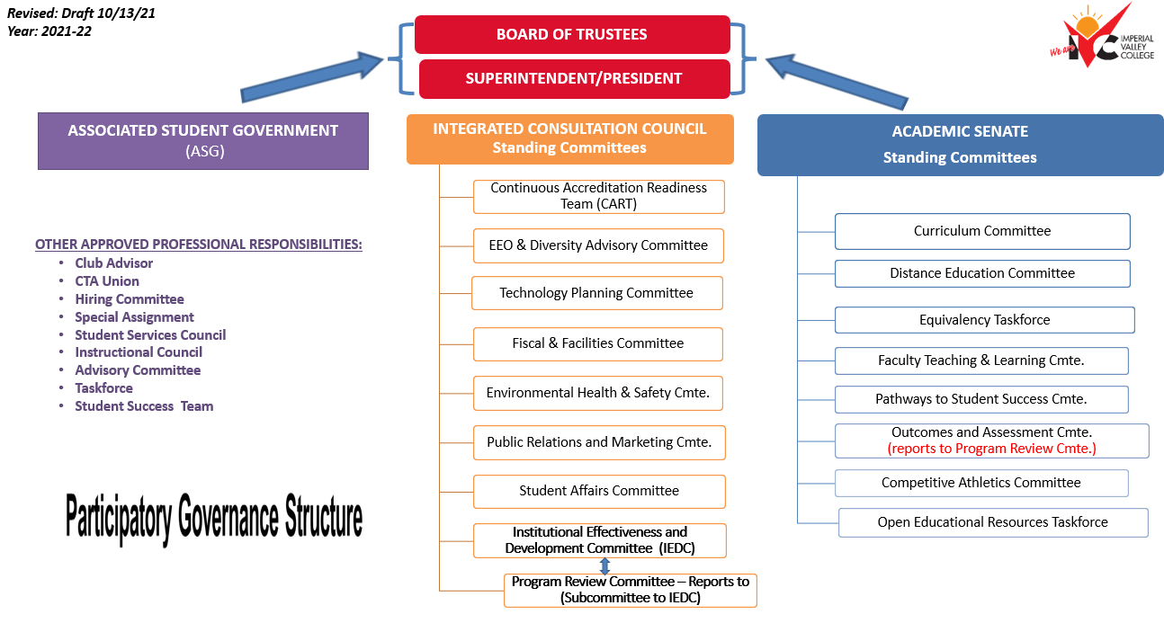

SECTION 3
INTEGRATED CONSULTATION COUNCIL
- INTEGRATED CONSULTATION COUNCIL (ICC)
The Integrated Consultation Council (ICC) is our primary committee for participatory governance and institutional planning. This committee provides recommendations based on input from all constituent groups and communicates those recommendations to all constituents in four areas: (1) strategic planning; (2) policy, procedure review and recommendation; (3) problem management, and (4) campus communication. The ICC’s primary role is to assure that all constituents have the right to participate in decision-making, including input in participatory planning committees, and to bring forward suggestions, ideas and needs within an inclusive and respectful communication environment. The right to participate brings with it the responsibility to participate in a manner that looks beyond the specific needs of individuals in order to meet the needs of students and the College District as a whole. By embracing participatory decision-making, we exemplify effective participation and therefore strengthen this essential core value at our institution. Effective participation is at the foundation for continuous quality improvement, which is required by accreditation standards and important for institutions of higher education to sustain a standard of excellence. Therefore, beyond compliance, participatory planning and decision-making is a means by which we can best assure our students the quality education they deserve. The following charts describe the ICC’s structure and how accreditation oversight is integrated into the College District’s institutional planning and governance structure. ICC will implement a philosophy of collegial consultation. The actions of the ICC will be guided by the operating principles set forth herein and will be based on the College District’s Comprehensive Master Plan, Accreditation Standards, Governing Board goals, constituency representative’s input and existing College District Policies and Administrative Procedures.

- PHILOSOPHY OF INTEGRATED CONSULTATION COUNCIL
Collegial consultation is a method of college management in which decision-makers, whether with primary or delegated authority, are committed to involving affected constituencies in decisions as much as possible. Collegial consultation is based upon individuals having a voice in decisions that affect them. Collegial consultation is carefully planned, instituted, and evaluated. It is designed to lead to effective participation in decision-making that unites constituencies, produces an improved college environment, and draws upon the strength of diversity. Collegial consultation includes the structures and processes for decision-making that engage students, staff, faculty, and administrators in reaching and implementing decisions that further the primary mission of the college—to educate students and place learning at the core of our existence. The groups formed to address college matters are properly charged and empowered, the members carefully selected, and processes clearly structured. The structures and processes for collegial consultation vary according to task.

In order for collegial consultation to work, there must exist a covenant of mutual trust, honesty, open agendas, equity, and respect for differing views. Essential to maintaining this covenant are open communications and feedback from all constituencies. All parties must commit to and take responsibility for fostering and maintaining an environment in which collegial consultation can occur, as well as being well informed regarding problems. The underlying structure is building community. By living, learning, and teaching the principles of community, we serve as a catalyst for individuals and groups to:
- Communicate with authenticity
- Deal with difficult problems
- Welcome and affirm diversity
- Bridge differences with integrity
- Relate with respect
In our decision-making processes, members of the constituent groups must commit to participating in the implementation of decisions made through collegial consultation processes and to working within legal and pragmatic parameters of their positions. The partners in collegial consultation acknowledge that traditional and legally mandated roles continue within the context of collegial consultation. Integrated Consultation Council shall provide a forum where representatives from all segments of the college will bring problems of college-wide interest.

- FUNCTIONS
For collegial consultation to work, there must exist a covenant of mutual trust, honesty, open agendas, equity, and respect for differing views. Essential to maintaining this covenant are open communications and feedback from all constituencies. All parties must commit to and take responsibility for fostering and maintaining an environment in which collegial consultation can occur, as well as being well informed regarding problems. The underlying structure is building community. By living, learning, and teaching the principles of community, we serve as a catalyst for individuals and groups to:
- Communicate with authenticity
- Deal with difficult problems
- Welcome and affirm diversity
- Bridge differences with integrity
- Relate with respect

In our decision-making processes, members of the constituent groups must commit to participating in the implementation of decisions made through collegial consultation processes and to working within legal and pragmatic parameters of their positions. The partners in collegial consultation acknowledge that traditional and legally mandated roles continue within the context of collegial consultation.

Integrated Consultation Council shall provide a forum where representatives from all segments of the college will bring problems of college-wide interest.

- PURPOSE
Integrated Consultation Council (ICC)

Mission/Purpose | The purpose of the Imperial Community College District’s Integrated Consultation Council (ICC) is to serve as the College District’s participatory planning and decision- making body in the areas of Strategic Planning, Policy and Procedure Review and Recommendation, Problem Management, and Campus Communication. All College District constituencies, as established by Board Policy No. 2510 Participation in Local Decision-Making will be represented on the ICC and shall have a voice in identifying, reviewing, and addressing College District’s needs and priorities. All committees and task forces operating within the College District, either directly or indirectly, will provide information or make recommendations to the ICC to ensure unity of purpose and efficiency of operations. The ICC will make its recommendations directly to the Superintendent/President.
Oversight Committee | None
Standing Committees: | - Continuous Accreditation Readiness Team (CART)  - Equal Employment Opportunity and Diversity Committee (EEODC)  - Technology Planning Committee (TPC)  - Fiscal and Facilities Committee (FFC)  - Institutional Effectiveness and Development Committee (IEDC)  - Environmental Health & Safety Committee (EH&SC)  - Public Relaations and Marketing Committee (PR&MC)
Subcommittees: | - Program Review Committee (PRC)  (this is a subcommittee of EDC)
Major Responsibilities: | - Reviewing and revising the College’s Mission on a tri-annual basis.  - Receiving information from all College District committees and task forces.  - Establishing subcommittees and task groups as deemed necessary.  - Periodically reviewing the Participatory Governance: Decision-Making and Committee Handbook and recommend modifications, if necessary, to improve institutional effectiveness.  - Receiving, reviewing, and establishing institutional priorities and goals based on program review data.  - Systematically evaluating progress being made by the ICC standing committees to achieve agreed-upon institutional goals in alignment with the College District’s Mission.  - Providing oversight and being responsible for integrating all institutional plans and documents and communicating these to the campus community.  - Addressing college-wide problems that may diminish our environment of trust which inhibits well-coordinated efforts and focus on students.  - Prioritizing institutional budget enhancement requests.  - Reviewing and making recommendations regarding College District policy and procedures.

- MEMBERSHIP

- COMPOSITION OF INTEGRATED CONSULTATION COUNCIL

Tri-Chair(s)
- Superintendent/President (non-voting member)
- Academic Senate President or Designee (faculty tiebreaker vote only)
- Classified Member (classified tiebreaker vote only)
Voting Membership
- 3 Administrators--Co-Chairs from committees designated by Superintendent/President
- 3 Faculty--Co-Chairs from committees designated by Academic Senate
- 2 Classified--Co-Chairs from committees designated by CSEA in absence of Classified Senate*
- 1 Confidential--Co-Chair from committee designated by Confidential employees
- 3 Students--designated by Associated Student Government
Alternates
- 2 Administrators-- designated by Superintendent/President
- 2 Faculty -- designated by Academic Senate
- 2 Classified—designated by CSEA in absence of Classified Senate*
- 1 Confidential -- designated by Confidential employees
- 2 Students—designated by ASG
Resource Members (Non-voting)
- Vice President for Academic Services (administrator tiebreaker vote only)
- Vice President for Administrative Services (unless they are also serving as an administrator representative, in which case they will have a vote)
- Vice President for Student Services & Equity (unless they are also serving as an administrator representative, in which case they will have a vote)
- Director of Institutional Research
- Academic Senate Vice-President

Note:
- *Classified members selected by CSEA in the absence of a Classified Senate must be from different departments.

- The Superintendent/President shall serve as a Tri-chair. The Academic Senate President shall serve as Tri-chair and shall serve as chair in the absence of the Superintendent/President. In the absence of both the Superintendent/President and the Academic Senate President, the Classified Representative shall serve as Chair.
- The Classified Representative shall serve as Tri-chair. In the absence of the all Tri- Chairs, the VP for Academic Services or Student Services and Equity shall serve as the Chair.
- Terms for Academic Senate President and Classified Representative will be in accordance with the Academic Senate President term, as stated in the Academic Senate bylaws.

- REMOVAL/REPLACEMENT OF MEMBERS:
Members may be removed only by the group that selected them (Academic Senate, CSEA, ASG, or the College President respectively). Any vacancies created by members resigning, changing office, or being removed shall be filled by the original designating group. Expectations of Integrated Consultation Council Members: Among the expectations for members of Integrated Consultation Council are the following:
- Members possess an open-mind and are willing to develop a college-wide perspective and an understanding of constituencies other than their own.
- Members are willing to commit to active and regular participation in College Planning meetings and activities, including subcommittees and task forces.
- Members may not miss more than three ICC meetings in an academic year. If members misses more than three meetings in an academic year, the member will be removed from ICC and replaced with one of the two alternates.
- Members keep lines of communication open by informing their constituents and others outside of problems and developments and by gathering input from their constituents to share with ICC.
- Members observe standards of ethical conduct.

- CHAIRS
The Superintendent/President shall serve as a Tri-chair.
The Academic Senate President shall serve as Tri-chair and shall serve as chair in the absence of the Superintendent/President. In the absence of both the Superintendent/President and the Academic Senate President, the Classified Representative shall serve as Chair.
The Classified Representative shall serve as Tri-chair. In the absence of the all Tri-Chairs, the VP for Academic Services or Student Services and Equity shall serve as the Chair.

- CLERICAL SUPPORT
The Office of the President will designate appropriate clerical support to ICC. Clerical assistance will include designating a person to take notes, preparing, and distributing agendas, attending meetings, and preparing minutes, and providing a repository of meeting notes and materials.

- MEETINGS
ICC meetings are open meetings and will abide by the Brown Act.

- QUORUM
A quorum for meetings will be 50% of ICC members plus one. A quorum requires attendance of member(s) from each unit.

- FREQUENCY
Meeting Times: Regular meeting times will be 9:30am to 11am the second Friday of each month , subject to change due to other institutional commitments. Special meetings, as defined by the Brown Act, may be called as needed.
Conduct of Meetings: Meetings of Integrated Consultation Council will be conducted in a flexible manner which promotes open discussions and full participation of all members and takes into account the nature of the agenda items.

- AGENDAS
Agenda-Building:
Items may be placed on the agenda in the following ways:
- Items for discussion will usually be determined at the close of the previous meeting of ICC.
- An ICC member may request that an item be placed on the agenda by submitting it to the President’s Office at least one week prior to the next regularly scheduled meeting.
- At the outset of a meeting, an ICC member may request the inclusion of an item for discussion. The item will be placed last on the agenda unless otherwise agreed to by the members present. If there is not sufficient time to discuss the item, it will be carried over to the next agenda or a special meeting may be called.
- Members of the Imperial Valley College campus community may request that an item of college concern be placed on the agenda by contacting their representative at least seven working days prior to the next regularly scheduled meeting.

The Integrated Consultation Council Tri-Chairs will be responsible for developing and approving the agendas. The Superintendent/President, Academic Senate President and Classified Representative will review with ICC all requests for agenda items. All agenda items will be given a time allotment as appropriate for the item.

- INTEREST-BASED PROBLEM SOLVING AND CONSENSUS

All ICC action will be made primarily through interest-based problem solving. The intent of interest-based problem solving is to reach consensus through discussion until all members present can support the decision, even though they may not believe it is the ideal choice. Consensus is demonstrated by a majority vote: The Tri-Chairs will ask for a vote of those who agree; a vote of those who object; and a vote of those who abstain. In the context of the ICC, interest-based problem solving shall be defined as the right of any member to prevent the passage of a motion by voting against it if they cannot support such a decision.

- Communications
All agendas will be distributed to ICC members with at least 72 hours per Brown Act. Committee chairs will inquire ICC members a week before if they would like to include anything on the agenda a week prior to each meeting. The agenda will then be created by classified staff supporting the committee which will include time, location, and details of the meetings to all constituents. The minutes from the previous meeting and agendas will be attached for members to review prior to each meeting. The supporting classified staff is responsible for posting agenda, meeting minutes, and any pertinent documents onto BoardDocs. Note: There will be annual committee assessments on an annual basis and bi-annual evaluations on the overall effectiveness of the committee. These assessments and bi-annual evaluations will be distributed by the Office of Institutional Research and will be evaluated by the Office of Institutional Effectiveness. The findings of the assessments and evaluations will be presented at the end of each academic year.

- COMMITTEES
ICC is responsible for developing, implementing, and monitoring the Integrated Planning Model in alignment with IVC’s Vision 2030 Comprehensive Master Plan.
The college’s Superintendent/President will abide by the Integrated Planning Model and processes and procedures established by ICC and will not make any edits or alterations unless there are extenuating circumstances that would support these changes for the betterment of all faculty, staff, administrators, and most importantly, our students.

- INSTITUTIONAL EFFECTIVENESS AND STRATEGIC PLANNING
IVC’s commitment to student success will be in alignment with all institutional priorities, state, and nation-wide initiatives. Institutional Effectiveness and Strategic Planning will ensure that all internal processes are in connection with state legislature and accrediting processes. The Accrediting Commission of Community and Junior Colleges (ACCJC) agency requires that we have a robust institution-wide planning and evaluation process that informs continuous improvements and the ways in which the institution includes all strategic planning on campus. IVC’s institutional effectiveness integrated model was created to capture, organize, and report the alignment with various requirements.

- INTEGRATED CONSULTATION COUNCIL FLOW CHART
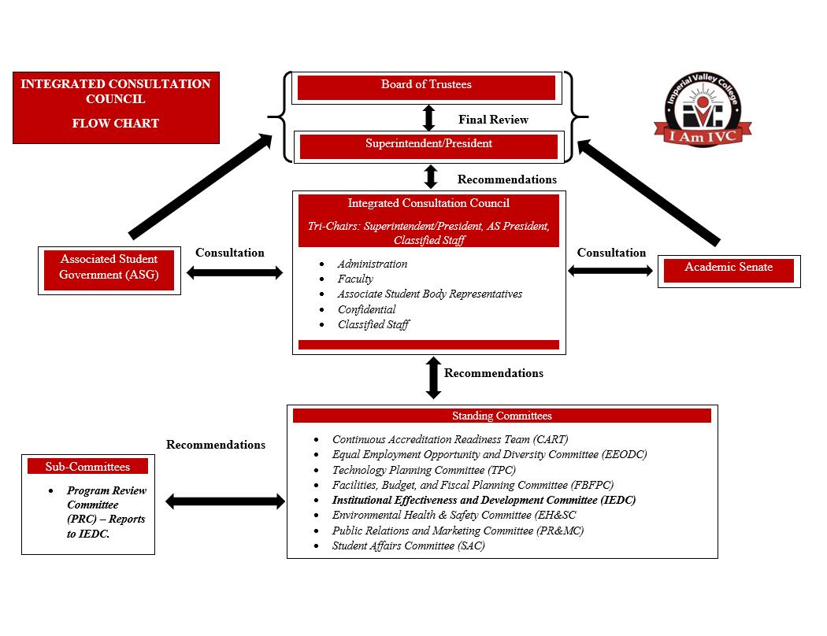

ICC BYLAWS
Here is the link to the most updated version of ICC’s bylaws.

SECTION 4
STANDING COMMITTEES
- CONTINUOUS ACCREDITATION READINESS TEAM (CART)
Role
The CART shall serve in an advisory capacity to the President’s Cabinet and the Academic Senate regarding matters of strategic and institutional planning to remain in compliance with eligibility and accrediting standards of the Accrediting Commission for Community and Junior Colleges (ACCJC) and Western Association of Schools and Colleges (WASC) and to move the College toward continuous program quality improvement.

Bylaws
Link: Board Docs

Mandate
Accreditation was changed from a six-year cycle to a seven-year cycle. The last site visit was based on an Institutional Self-Evaluation Report and took place March 11-14, 2019.
IVC is accredited by the Accreditation Commission for Community and Junior Colleges. ACCJC operates under the corporate entity the Western Association of Schools and Colleges (WASC).
Meeting Schedule
Twice a month: Second and fourth Friday from 10:00am-11:00am.
Reporting Relationship
Integrated Consultation Council
Membership
A. The CART is directed by the Vice President for Academic Services and one or two co‐chairs. B. The CART shall be composed of the following voting members:
- Vice President for Academic Services (CIO &ALO)
- All Department Chairs or theirdesignees
- Educational Master Plan Committee (EMPC) Chair
- 4)Program Review Committee Chair
- Institutional Effectiveness and Development Committee Chair
- Academic Senate representative
- Integrated Consultation Council representative
- Counseling representative
- Human Resources representative
- Administrative Services representative
- Two ASGrepresentatives
C. The CART shall include the following CART consultant members asneeded:
- Superintendent/President
- Vice Presidents for Student Services and Administrative Services
- Instructional and Student Services Deans
- Director of Fiscal Services
- Institutional Researcher
- Distance Education Coordinator
- Student Learning Outcome Coordinator
- Basic Skills Coordinator Pathways to Student Success Committee Coordinator
- CTA representative
D. The CART may include – as non‐voting members – any certificated or classified staff member who wishes to participate.
E. All members of CART have speaking privileges at meetings. Only voting members may present motions.
F. Rights and Responsibilities Each member shall be encouraged to present his/her individual viewpoint and shall not represent the viewpoints of an administrative unit or a specific job function unless specifically disclosed at the meeting.
G. Non‐members The CART will hold open meetings, and visitors are welcome.

CART Bylaws: 16 April 2019 (revised 09-17-21)
- EQUAL EMPLOYMENT OPPORTUNITY AND DIVERSITY COMMITTEE (EEODC)
Role
The purpose of the EEO & Diversity Committee is to afford the campus community a chance to provide input and make recommendations regarding EEO, diversity, processes regarding staffing, recruitment, screening, about staffing-related issues and activities, and to take action upon recommendations from feeder subcommittees. The committee will make recommendations to the shared governance committees and/or the Superintendent/President and has the following broad categories of scope within its purview:
• Policies and Procedures regarding diversity, EEO, non-discrimination, sexual harassment, complaint procedures, recruitment and screening.
• EEO & Diversity multiple measures
• EEO Plan
• Staffing Plan

Bylaws
Link: Board Docs

Meeting Schedule
At its first meeting of each academic year the EEO & Diversity Advisory Committee will meet on the 3rd Monday of each month. The Committee will meet at least once a month during the school year. A schedule of the meetings will be provided on the website.

Reporting Relationship
Integration Consultation Council

Membership
1. The following college constituencies retain all rights granted by law and/or regulations. The five groups represented in this participatory governance structure are faculty, classified staff, classified managers/confidential, students, and administrators.
2. The voting members of the EEO & Diversity Advisory Committee are:
- 2 faculty members appointed by the Academic Senate and 1 alternate.
- 2 classified members appointed by CSEA and 1 alternate.
- 2 administrators: The Chief Human Resources Officer (CHRO) and one other appointed by the Administrative Council and 1 alternate.
- 1 member of the Classified Management and 1 alternate
- 1 member of the Classified Confidential and 1 alternate
- 2 part-time faculty members appointed by the PTFA and 1 alternate.
- 2 students appointed by the ASG and 1 alternate.
Non-voting members include:
- The HR Technician will be the recording secretary.
- The Human Resource Analysts will be available for consultation purposes.
3. A Co-Chair will be elected, from within the voting membership, by the members of the EEO & Diversity Advisory Committee.
4. The EEO & Diversity Advisory Committee may create ad hoc committees as needed to address college wide issues and task forces to address specific (single item) issues.
5. The CHRO will serve as the Chair of the EEO & Diversity Advisory, who is also a voting member (for purposes of tie breaking, etc. as outlined in Robert’s Rules of Order).
6. The Co-Chair of the EEO & Diversity Advisory Committee shall be elected for a two-year term by the committee and be a voting member. In the absence of the Chair, the Co-Chair will conduct meetings of the EEO & Diversity Advisory Committee.

Revised on 10/18/21

- TECHNOLOGY PLANNING COMMITTEE (TPC)
Role
The purpose of the Technology Planning Committee is to serve as the College District’s participatory planning and decision-making body by providing recommendations directly to the Integrated Consultation Council based on input from all constituent groups in the area of technology, both informational and educational. The TPC will coordinate campus technology activities, address technology needs and issues, and take action upon recommendations from all constituent groups.

Bylaws
Link: Board Docs

Meeting Schedule
The Committee will meet the 1st Thursday of each month between 3:00 and 4:00 pm as part of the Integrated Consultation Council calendar.

Reporting Structure
Integrated Consultation Council

Membership
- The following college constituencies retain all rights granted by law and/or regulations. The five groups represented in this shared governance structure are faculty, classified staff, confidential, students, and administrators.
- The voting members of the TPC are:
  - 2 faculty members appointed by the Academic Senate and 1 alternate.
  - 2 classified members appointed by CSEA and 1 alternate.
  - 2 administrative members appointed by the Administrative Council and 1 alternate.
  - 1 member of the Classified Confidential and 1 alternate
  - 2 students appointed by the ASG and 1 alternate.
- The Chair will be the Chief Technology Officer or other as assigned by the Chief Technology Officer. The Co-Chair will be elected, from within the voting membership, by the members of the TPC.
- The TPC may create ad hoc committees as needed to address college wide issues and task forces to address specific (single item) issues.

- Fiscal and Facilities Committee (FFC)
Role
Coordinate and integrate college plans and establish budget priorities consistent with the college's vision and mission statements, with recommendations, expressed in dollars, made to the Superintendent/President.
Recommend budget priorities to the Superintendent/President; final recommending authority to the Board of Trustees rests with the Superintendent/President; final approval authority rests with the Board of Trustees.
Review the Tentative and Adopted budgets for consistency with annual institutional goals and objectives, college plans, and the planning and budget philosophy.

Bylaws
Link: Board Docs

Mandate
The committee was established March 11, 1998, Res. 11338 Bylaws, amended July 15, 2009, Res. 14423.
Meeting Schedule
4th Wednesday of the month, 1:00 p.m. (Fall and Spring semesters)
Reporting Structure
Integrated Consultation Council
Membership
Representative Areas | # of Representatives
Chairs | 2 – (Faculty and Administrator)
Academic Senate | 2 – (AS Representative)
ASG | 3 – (ASG President and Representative)
Administrators | 5 – (Select Divisions and/or Departments)
Faculty | 5 – (Select Divisions and/or Departments)

- INSTITUTIONAL EFFECTIVENESS AND DEVELOPMENT COMMITTEE (IEDC)
Role
The Institutional Effectiveness and Development Committee is a participatory governance committee that reports directly to Integrated Consultation Council. IEDC was created to advance the overall planning for the institution. To ensure continuous and sustainable quality assurance and improvement at the college, IEDC is responsible for the college’s planning that adheres to accreditation standards; goals, objectives, and priorities, by recommending changes as informed by the college’s needs. Integrated planning will be at the forefront of the committee’s priorities.

Bylaws
Link: Board Docs

Mandate
Support evidenced-based documentation for ICC and accreditation efforts.

Meeting Schedule
1st and 3rd Tuesday of the month, 3:00 p.m. (Fall and Spring semesters)

Reporting Structure
Integrated Consultation Council

Membership
Co-Chair(s)
• Associate Dean of Institutional Effectiveness, Equity, and Student Success
• Faculty Member
Voting Membership
• Vice-President of Student Services & Equity
• Vice-President of Academic Services
• Dean of Arts, Letters, and Learning Services
• Dean of Workforce and Economic Development
• Dean of Student Affairs, Enrollment Services & Campus Safety
• Dean of Student Services and Special Projects
• Associate Dean of Institutional Effectiveness, Equity, and Student Success
• Director of Institutional Research
• All Department Chairs or Designee
• CART (Continuous Accreditation Readiness Team) Chair
• Pathways to Student Success Committee Chair(s) (only one vote)
• Academic Senate Representative
• Integrated Consultation Council Representative
• ASG Representative
• Classified Representative
• Classified Confidential Representative
• Classified Administrator Representative
Resource Members (Non-voting)
• Superintendent/President
• Vice President for Administrative Services
• Distance Education Coordinator
• Outcomes & Assessment Coordinator

- ENVIRONMENTAL HEALTH & SAFETY COMMITTEE (EHSC)
Role
The Environmental Health and Safety Committee is to carry out its mission to foster excellence in education for its students, the district must provide a safe learning and working environment for its students, faculty, and staff. The purpose of the EHSC is to create and maintain such an environment.
Webpage: https://www.imperial.edu/faculty-and-staff/campus-committees/college-council/subcommittees/facilities-and-environmental-health-and-safety/older-historical-data/environmental-health-and-safety/

Bylaws
- Under Development
Mandate
Standard III.B.1 The institution provides safe and sufficient physical resources that support and assure the integrity and quality of its programs and services, regardless of location or means of delivery.
Standard IIIB.1.b The institution assures that physical resources at all locations where it offers courses, programs, and services are constructed and maintained to assure access, safety, security, and a healthful learning and working environment.
Meeting Schedule
4th Thursday of the month, 3:00 p.m. (Fall and Spring semesters)
Reporting Structure
Integrated Consultation Council
Membership
Representative Areas | # of Representatives
Chairs | 2 – (Faculty and Administrator)
Academic Senate | 2 – (AS Representative)
ASG | 3 – (ASG President and Representative)
Administrators | 5 – (Select Divisions and/or Departments)
Faculty | 5 – (Select Divisions and/or Departments)

- PUBLIC RELATIONS AND MARKETING COMMITTEE (PRMC)
Role
The IVC Public Relations and Marketing Committee is responsible for providing guidance and support for both internal and external initiatives and communication strategies that promote and enhance the mission of Imperial Valley College.

Bylaws
Link: Board Docs

Mandate

Meeting Schedule
1st Wednesday of the month, 3:00 p.m. (Fall and Spring semesters)

Reporting Structure
Integrated Consultation Council

Membership
1. The following college constituencies retain all rights granted by law and/or regulations. The five groups represented in this shared governance structure are faculty, classified staff, classified managers/confidential, students, and administrators.
2. The permanent members of the PRMC are: • At least two faculty members appointed by Academic Senate
- At least two classified members appointed by CSEA
- At least two members of the CMCA appointed by CMCA
- At least two students at large appointed by ASG
- At least one administrator appointed by the Administrative Council
- Public Relations consultant
*Terms for faculty, classified, classified managers/confidential, public relations consultant and administrators shall be for two years.
*Terms for student representatives shall be for one year.
3. If the following departments are not represented by permanent members, additional members can be appointed by the President: IT, Student Affairs, the Athletics Department, the IVC Foundation and Applied Sciences.
4. The Chair and Co-Chair will be elected by the members of the Public Relations and Marketing Committee.
5. The PRMC may create ad hoc committees as needed to address college wide issues and task forces to address specific (single item) issues.

- STUDENT AFFAIRS COMMITTEE (SAC)
Role
The purpose/function of the Student Affairs Advisory Committee is to evaluate and make
recommendations concerning the various areas of student affairs. This committee shall be
responsible for recommending policies regarding student activities, clubs, assemblies, commencement, disciplinary matters pertaining to disciplinary appeals and other student activities.

Bylaws
Link: Board Docs

Meeting Schedule
2nd Thursday of the month, 3:00 p.m. (Fall and Spring semesters)

Reporting Structure
Integrated Consultation Council

Membership
The chairperson of the committee shall be the Dean Student Affairs and Enrollment Services and the Co-chair shall be a faculty member. The following members shall be appointed by the Superintendent/President: at least four faculty members and four classified staff, and four students will be appointed by the Associated Student Government President. A faculty member shall be selected by the committee to serve as chairperson of the disciplinary appeals board.
The SAC may create ad hoc committees as needed to address student affairs issues and task forces to address specific issues.

SECTION 5
SUBCOMMITTEE

- PROGRAM REVIEW COMMITTEE (PRC)
Role
The Program Review Committee reports to IEDC. The composition of the PRC is consistent with that of standing committees that includes the following area representatives: classified, students, faculty, and administrators.
The committee has the following responsibilities:
- Review and modify the program review timeline.
- Review and modify guidelines, forms, criteria, and development of the handbook on an annual basis.
- Determine and publish schedules on a need’s basis for all comprehensive and update years. This is based on the 3-year cycle for program review.
- Provide training to individual groups and to the overall college.
- Provide guidance and support to all department and program chairs, administrators, and staff involved.
- Prepare annual evaluation program review survey with the help of the institutional research and institutional effectiveness department.
- Consult on an on-going basis with IEDC chairs for reporting purposes.
- At the conclusion of each program review year, the committee will be responsible for providing a final report with identified major milestones to present at IEDC, Academic Senate, and ICC.
Bylaws
  - Under Development
Mandate
The Program Review Committee (PRC) has primary responsible for providing guidance to the College regarding the process and documents for the review. PRC plays a critical role in evaluating and providing feedback on the quality of the program review documents submitted by the areas undergoing comprehensive program reviews to facilitate information (i.e. data) and submission of their program reviews in accordance to their cycle.

Meeting Schedule
TBD, 3:00 p.m. (Fall and Spring semesters)

Reporting Structure
Institutional Effectiveness and Development Committee

Membership

SECTION 6
PROGRAM REVIEW PROCESS
PROGRAM REVIEW PROCESS OVERVIEW
The purpose of the IVC’s program review process is to review, analyze, and assess the content, currency, direction, and quality of all programs and services in order to invest in the unit’s future.

The intent of the program review process is to promote student-centered educational and
service excellence by engaging all college units in self-examination and self-improvement.
The review process is to be broad-based, accessible, and integrated into other college -wide
processes, such as accreditation, budget, and planning.

The information gathered and analyzed in program review is an integral part in planning,
decision-making, personnel development, program improvement, and optimal utilization of
the college’s budgetary resources.

Each unit’s final report should be designed to give insight into the past, present and future through the following three broad questions:
- What has the program accomplished in the past year?
- Where is the program now?
- Where should it go from here?
Specifically, each unit’s program review will:
- Ensure that all college programs and services are functioning in support of the college's student-centered mission.
- Ensure that all program goals, objectives, and resource requests are aligned with one or
more institutional goals and objectives and as of 2020-21 the California Community
College’s Chancellors Office Vision for Success goals.
- Promote steady improvement in the quality and currency of all college programs and
services through the use of SMART goals.
- Provide a body of evidence of institutional effectiveness at all levels for accreditation.
- Support the integration of the College Mission in all programs and services.
- Facilitate self-analysis of each unit’s functions and its relationship to college goals and
the internal and external conditions that impact its operation.
- Note areas of strength and acknowledge accomplishments.
- Note areas in need of improvement to alert the college to concerns/issues in time for
proactive solutions.
- Provide a vehicle for information-based, timely, collegial consultation for budget.- consideration to support development and improvement of all college programs and
services.
The PRC will periodically amend the list of departments, programs, and units that are
responsible to conduct program review.

Program Review Components:
The components that comprise a unit’s program review generally include the following:
- Statistical data that describe the program/unit in terms of student contact, learning outcomes and staff assigned to the unit.
- SLO/SAO & PLO summary – Explain how your assessment of student learning outcomes
(SLO) or Service Area Outcomes (SAOs) led your planning efforts. Also, provide any
information of how this assessment drives the Program Leaning Outcomes (PLOs) for the
college.
- Alignment with Vision for Success Goals
- Survey results that indicate the customers’ degree of satisfaction with the program or
service, learning outcomes and suggestions for improvement.
- The comprehensive program review includes a self-study of the program/unit that addresses its long-term goals, functions and services with evidence supporting one or more institutional goal; and an evaluation of academic/student data and/or survey results.
- The self-study should also include recommendations for improvement as well as a work plan that outlines resources required for implementation based upon analysis of data and identifies one or more institutional goals the resource supports.
- Service areas complete a SWOT analysis as part of the self-study; academic areas complete a thorough analysis of enrollment, student outcomes, and linkage to existing college plans.
*Note: Please refer to the specific guidelines on each comprehensive Program Review for
additional details regarding the specific components of Academic and non-academic units.
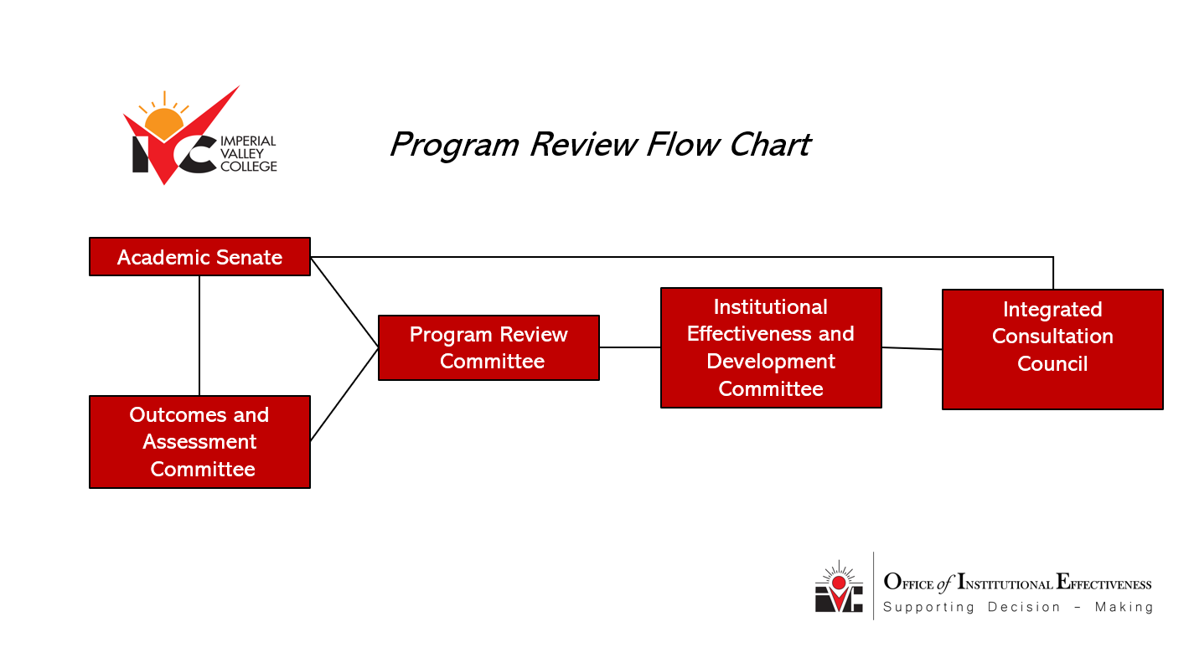

BUDGET ENHANCEMENT PROCESS
Prioritization & Funding:
Program reviews will serve as a basis for annual prioritization, funding and budget planning. Each program/unit will submit the completed program reviews with any budget enhancement requests to be incorporated into the college’s annual budget process.
The Offices of Institutional Research and Institutional Effectiveness shall maintain copies of all program review reports as a permanent archive and will provide data as needed for all program review reports.
Timeline:
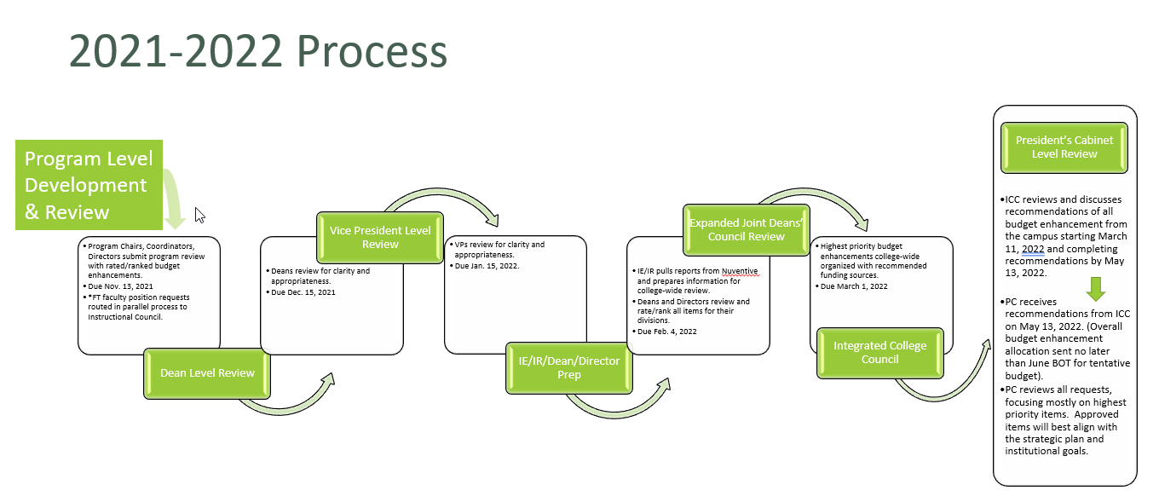

SECTION 7
ACADEMIC SENATE
- ACADEMIC SENATE

Role
The purpose of the Academic Senate for Imperial Valley College is to:
- Represent the faculty of Imperial Valley College to ensure a formal and effective procedure for participating in the formation of policies and procedures on Academic and Professional matters.
- Promote and preserve the integrity of the educational program.
- Facilitate communication between the faculty, the Board of Trustees, and the administration.
- Develop policies and procedures related to Academic and Professional matters and to promote their implementation.
- Assist the members of the faculty of Imperial Valley College in exercising their voice on Academic and Professional matters.
- Develop, communicate, and encourage ethical and professional conduct.
- Advise the Board of Trustees and administration on Academic and Professional matters.
- Represent Imperial Valley College to other faculties and to the Academic Senate of California Community Colleges.
- Reach mutual agreement with the College President on matters relating to equivalency, hiring procedures, administrative retreat rights, and Academic and Professional matters pursuant to the provisions of the Education Code.
Reporting Structure
Integrated Consultation Council and President’s Cabinet

SECTION 7
REDUCED CONFLICT SCHEDULE, UNIFORM RECORDING, AND FLOW
COMMITTEE SCHEDULE PROPOSED
IVC is committed to minimize time conflicts for committee meetings to maximize participation. The proposed committee schedule attempts to use College Hour as the primary time for participatory governance committee meetings. With the exception of larger committees (ICC) and Academic Senate and ASG, all standing committees, subcommittees, and important college-wide meetings are captured in this schedule. Some operational meetings are also provided scheduling options to further reduce conflict.
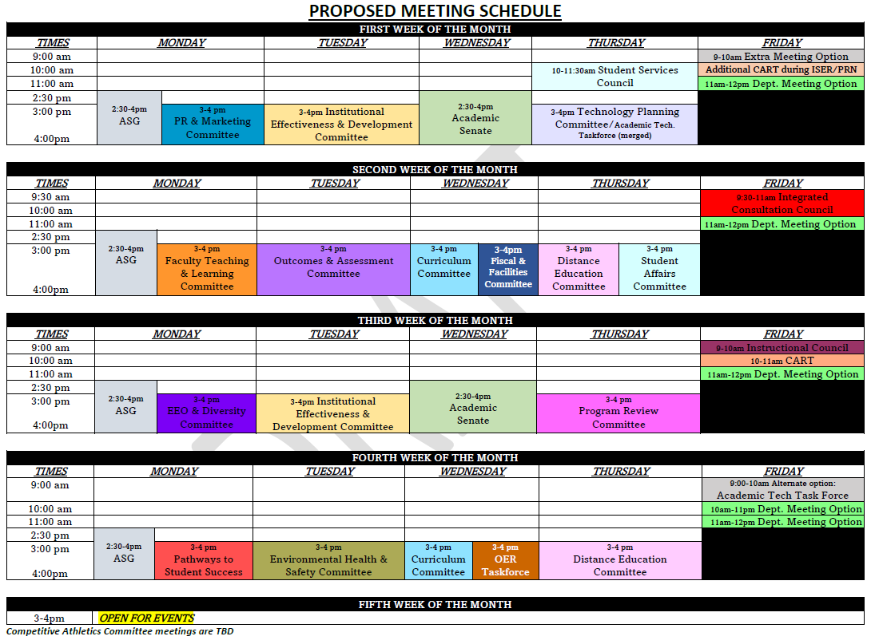
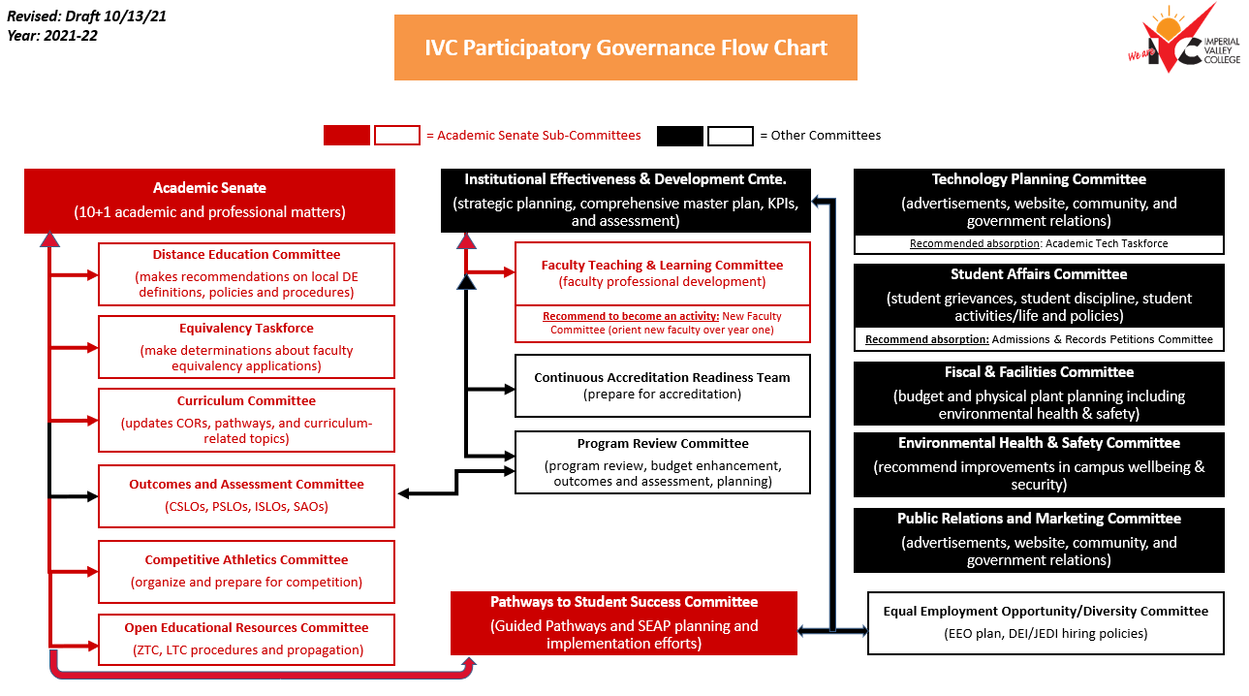
GOVERNANCE RECORDING & TEMPLATES
IVC desires to support the best record keeping for participatory governance. Therefore, each governance committee is supported with a dedicated recorder who assists the chairs/co-chairs with agendas, minutes, posting, and other committee records. The templates for agendas and minutes can be found in the appendices of this document. All records are posted in a uniform manner on the central platform of BoardDocs.

SECTION 8
GOVERNANCE EVALUATION AND SURVEY
Committee Evaluation Form
At IVC, each standing committee will submit a committee evaluation form. The purpose of the committee evaluation is to identify the purpose of the committee and the major milestones and benchmarks that have been evaluated toward the end of the year to ensure that the committees are effective and meeting the institutional priorties of the campus.

See Appendix D for committee evaluation form.

Governance Evaluation Survey
At the end of each academic term, in addition to each committee evaluations, there will be a governance evaluation survey issued for all constiuents. The survey will serve to evaluate the effectiveness of the governance processes toward supporting academic quality and accomplishing the mission. The results of the evaluation survey will be reviewed by ICC and used for planning improvements to governance processes. The survey has four major components: 1) General Information, 2) Integration, 3) Culture, and 4) Operations of governance structure. The Offices of Institutional Effectiveness and Research will prepare the survey in Spring of 2022. The survey will be developed by the Institutional Effeciveness and Development Committee and final input will be provided by ICC. Once final voting has taken place, the survey will be distributed college-wide. The results will be presented the following academic year.

See Appendix E for governance committee evaluation survey.

Governance Evaluation Timeline

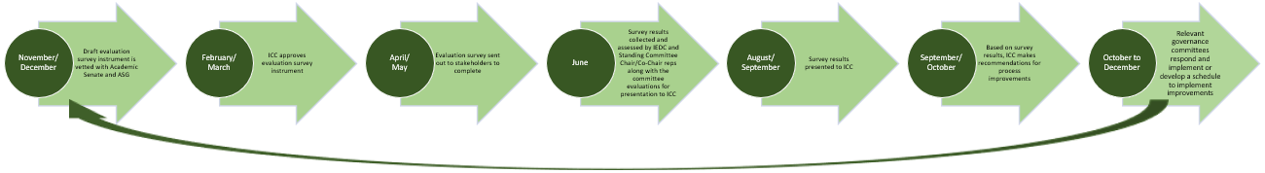

Appendix A
Communication Email
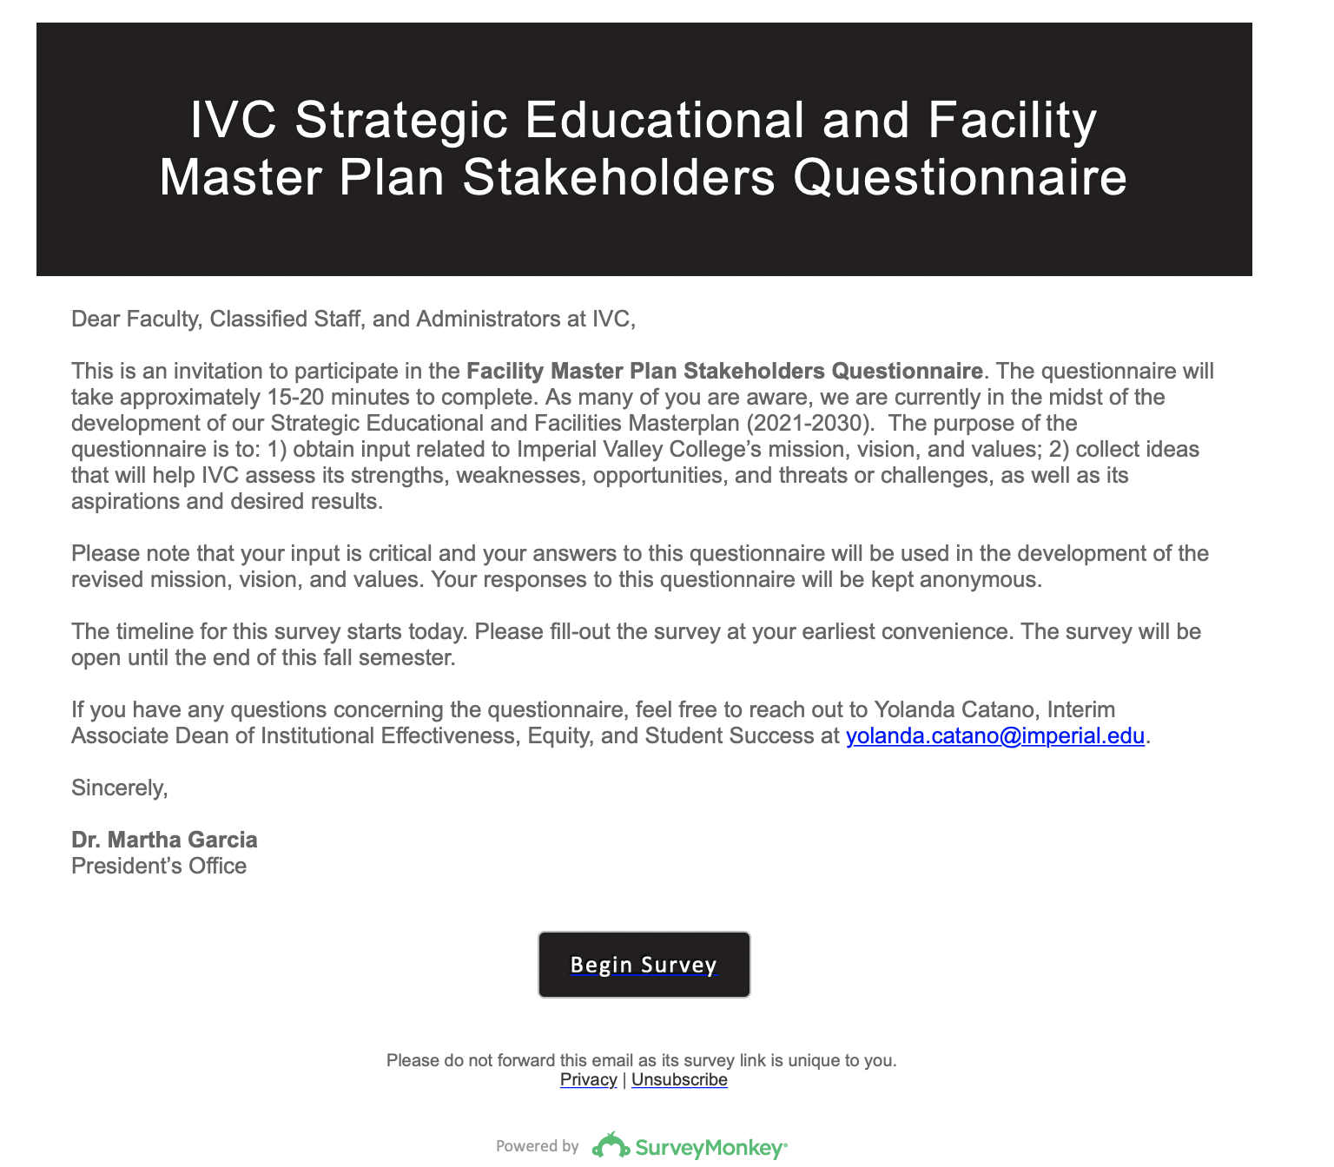

Appendix B
Revising BP/Aps in Board Docs
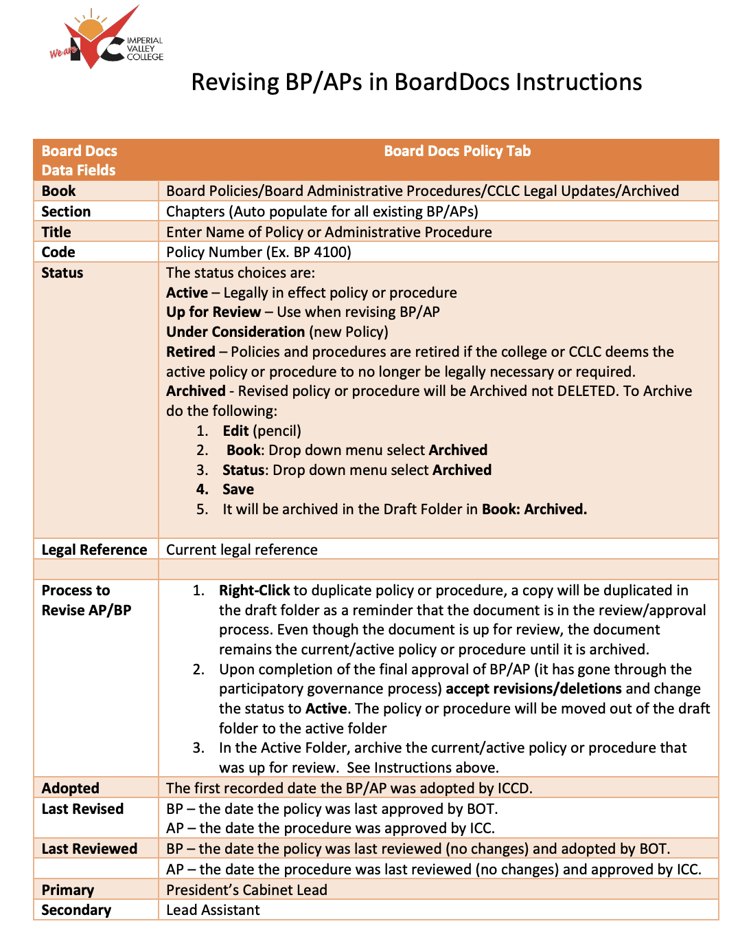
Appendix C
Meeting Minutes Template
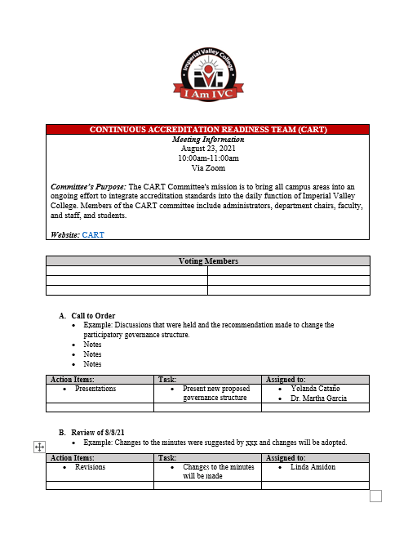

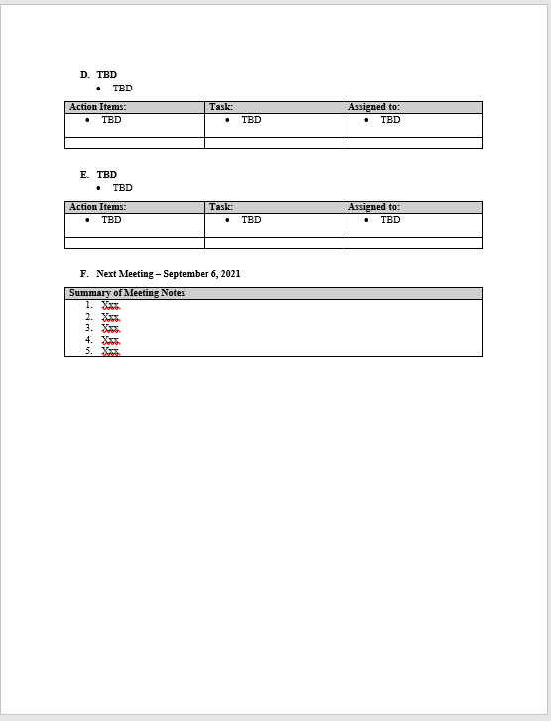

Appendix D
Committee Evaluation Form
Committee Name
Committee Charge (Summary)
For Academic Year 17/18 |  |  |  |  |  |  | Date of Evaluation
Month |  | Mtg Date | #  Members Present | Agenda Sent  1=Yes 0=No |  | Minutes Posted  1=Yes 0=No | Please list the major issues or tasks addressed at each meeting
July
Aug
Sept
Oct
Nov
Dec
Jan
Feb
Mar
Apr
May
June
Avg Attendance |  |  |  | % |  | %
 | Major Accomplishments or Achievements in Past Year |  |  | 1
 |  |  |  | 2
 |  |  |  | 3
 | Major Obstacles or Problems with Committee Function |  |  | 1
 |  |  |  | 2
 |  |  |  | 3
 | Recommendations for Improving Process or Efficiency
 |  |  |  | 2
 |  |  |  | 3
 | Review of Goals from Previous Year & Related Institutional Goal |  |  | 1  Finalize Professional Development Plan
 |  |  |  | 2 Continue building the online library
 |  |  |  | 3
 | Committee Goals (if appropriate) for Coming Year and list Related Institutional Goal |  |  | 1 | Related to Institutional Goal:
 |  |  |  | 2 | Related to Institutional Goal:
 |  |  |  | 3 | Related to Institutional Goal:
 | Chair/Co-Chair Signature |  |  | x
 | Typed or Printed Name
 | Chair/Co-Chair Signature |  |  | x
 | Typed or Printed Name
 |  |  |  |  | IVC Institutional Goals
Goal A
Provide all students with excellent academic programs and clear pathways to reach the timely completion of their educational goals.

Goal B
Ensure Learning and support the success of all students who meet their education and career goals.
Goal C
Align IVC Programs to labor market demands.
Goal D
Strengthen a culture of equity, diversity, inclusion, and social justice.

Goal E
Develop and implement responsible and sustainable policies and practices in the allocation and stewardship of all resources to support student access, equity, and success.
 |  |  |  |  | IVC Mission
The mission of IVC is to foster excellence in education that challenges students of every background to develop their intellect, character, & abilities; to assist students in achieving their educational & career goals; and to be responsible to the greater
community.

Revised on 10/25/21

Appendix E
Imperial Valley College Governance Committee Evaluation Survey 2022
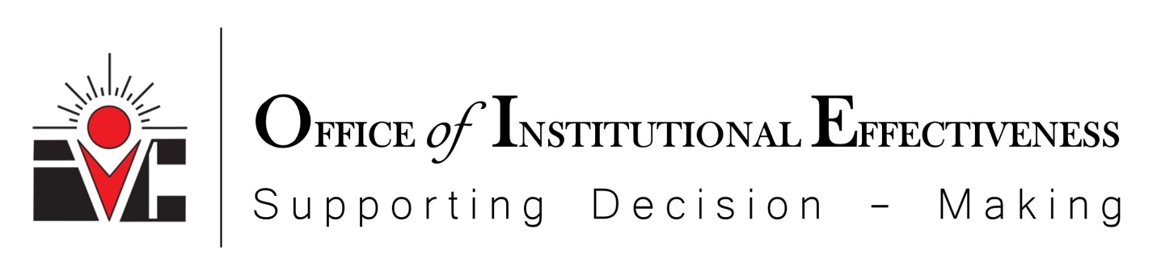

Imperial Valley College Governance Committee Evaluation Survey 2022
General
- Please identify your current position with Imperial Valley College.
  - Full-time Faculty
  - Part-time Faculty
  - Classified Staff
  - Confidential
  - Administration
  - Student
  - Other (please specify)
    - Blank Option
- Please select the committee you are evaluating in this survey. (If you serve on more than one committee, pleas select only one and respond to all survey questions accordingly)
  - Integrated Consultation Council
  - Institutional Effetiveness and Devlopment Committee
  - Program Review Committee
  - Continuous Accreditation Readiness Team (CART)
  - EEO & Diverssity Advisory Committee
  - Technology Planning Committee
  - Facilities, Budget and Fisal Planning Committee
  - Environmental Health & Safety
  - Public Relations and Marketing
  - Student Affairs Committee
  - Academic Senate
  - Curriculum Committee
  - Distance Education Committee
  - Equivalency Committee
  - Faculty Orientation
  - Faculty Teaching and Learning
  - Learning Support Services
  - Pathway to Student Success
  - Outcomes and Assessment Committee
  - Open Education Resource Committee
  - ASG
  - Other Assignments
- How many years have you served continuously on the committee you selected?
  - Less than 1 year
  - 1-3 years
  - 3-5 years
  - More than 5 years
- Do you expect to serve on the committee you are evaluating during the next academic year?
  - Yes
  - No
  - Unsure
- If you answered ‘no’ or ‘unsure’ on Question #4, please briefly explain why you chose that response.
  - Open Comment
Integration
- Please rate to what extent the committee’s activities during the current academic year are integrated with Imperial Valley College as a whole.
  - The Committee has clear goals/objectives.
    - Strongly disagree
    - Disagree
    - Agree
    - Strongly Agree
  - The Committee goals/objectives are clearly aligned with Imperial Valley College’s goals and mission statement.
    - Strongly disagree
    - Disagree
    - Agree
    - Strongly Agree
  - The work of the Committee is regularly communicated with other governance groups.
    - Strongly disagree
    - Disagree
    - Agree
    - Strongly Agree
  - The work of the Committee is regularly communicated with the campus at-large.
    - Strongly disagree
    - Disagree
    - Agree
    - Strongly Agree
- Please provide any additional commentary related to the Committees Integration with the larger campus community.
    - Comments
Culture
- Please indicate the extent to which you agree or disagree with the statements regarding the culture of the committee you have served on during the current academic year.
  - I feel comfortable contributing ideas.
    - Strongly disagree
    - Disagree
    - Agree
    - Strongly agree
  - My ideas are treated with respect, whether or not others agree with them.
    - Strongly disagree
    - Disagree
    - Agree
    - Strongly agree
  - I often engage in meaningful dialogue about agenda items with other members of the committee.
    - Strongly disagree
    - Disagree
    - Agree
    - Strongly agree
  - Meaningful dialogue often leads to actionable items.
    - Strongly disagree
    - Disagree
    - Agree
    - Strongly agree
  - Members are given adequate time to process information and make decision/recommendations.
    - Strongly disagree
    - Disagree
    - Agree
    - Strongly agree
  - The decision-making process is based on relevant, accurate, and timely data.
    - Strongly disagree
    - Disagree
    - Agree
    - Strongly agree
  - Members are given adequate information to make decisions/recommendations.
    - Strongly disagree
    - Disagree
    - Agree
    - Strongly agree
- Please share additional information you have related to the Committee’s Culture.
  - Comments

Operations

- Please rate the following operational aspects of the committee you served on during the academic year.
  - Orientation is available for new members.
    - Strongly disagree
    - Disagree
    - Agree
    - Strongly Agree
  - Meetings are scheduled for the appropriate amount of time to accomplish the goals of the committee.
    - Strongly disagree
    - Disagree
    - Agree
    - Strongly agree
  - Meetings are frequent enough to meet the goals of the committee.
    - Strongly disagree
    - Disagree
    - Agree
    - Strongly agree
  - The composition of the committee is appropriate for the goals of the committee.
    - Strongly disagree
    - Disagree
    - Agree
    - Strongly agree
  - Meetings usually start within 5 minutes of expected start time.
    - Strongly disagree
    - Disagree
    - Agree
    - Strongly agree
  - Meeting agendas are available prior to the start of each committee meeting.
    - Strongly disagree
    - Disagree
    - Agree
    - Strongly agree
  - Drafts of the minutes of prior meetings are provided with enough time to read and evaluate them.
    - Strongly disagree
    - Disagree
    - Agree
    - Strongly agree
  - Meetings are well attended with enough members regularly present to complete the work.
    - Strongly disagree
    - Disagree
    - Agree
    - Strongly agree
  - Committee website is updated to include accurate and correct information.
    - Strongly disagree
    - Disagree
    - Agree
    - Strongly disagree
  - Adequate resources (budget/support) are available.
    - Strongly disagree
    - Disagree
    - Agree
    - Strongly agree

Additional Information

- Please share any additional information you have related to the Committee’s operations.
  - Comments
- Please list three of the most important achievements of the committee during the current academic year. If you don’t think there have been any achievements during this time, please explain why.
- Have you experience ed any barrier(s) that keep the committee from achieving its goals? (Please be specific)
- What support do you need or does the committee need to continue to work hard toward the committee goals?
- Anything else you’d like to express or share regarding your experiences with the Committee? (Optional)

