Guide to entering the narrative for Section II.B in SPOL Accreditation Module

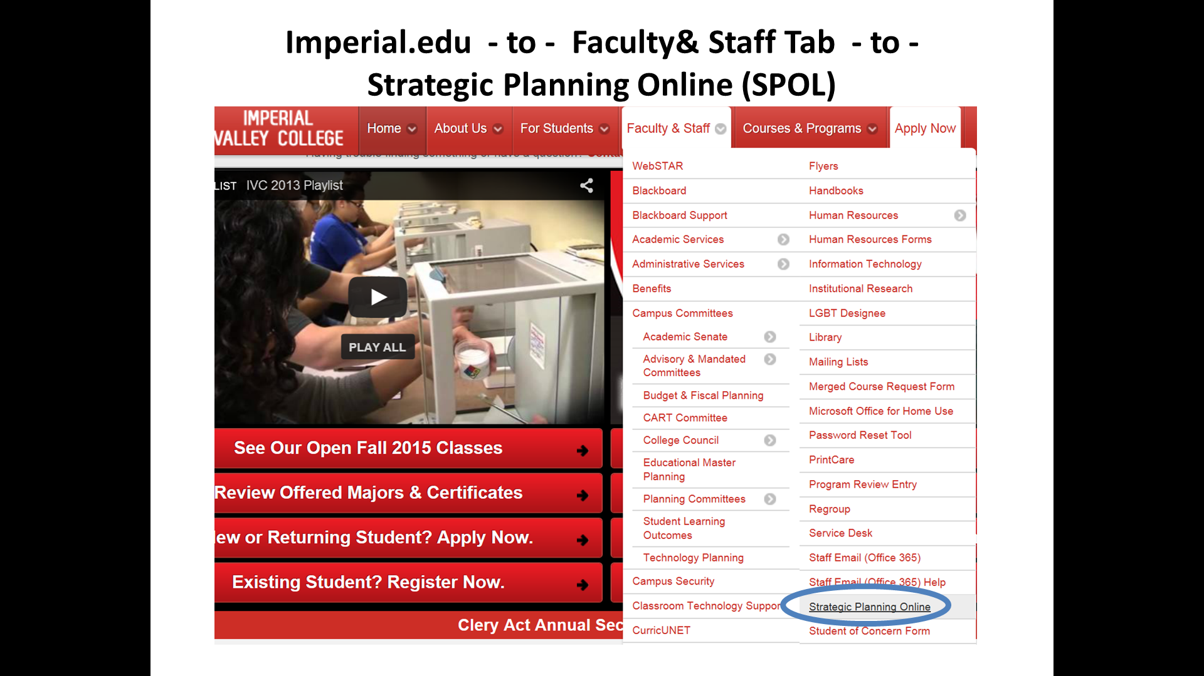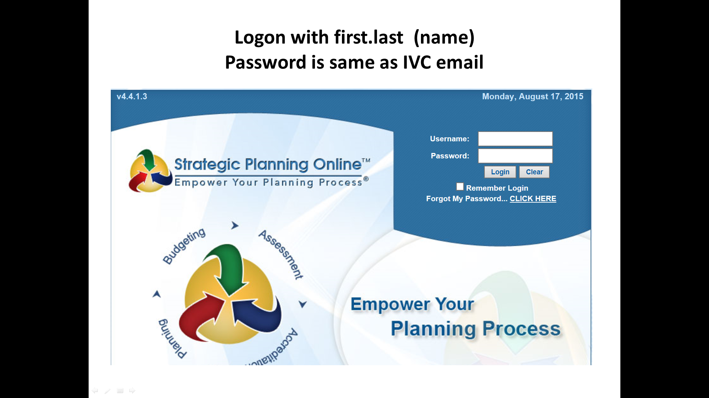

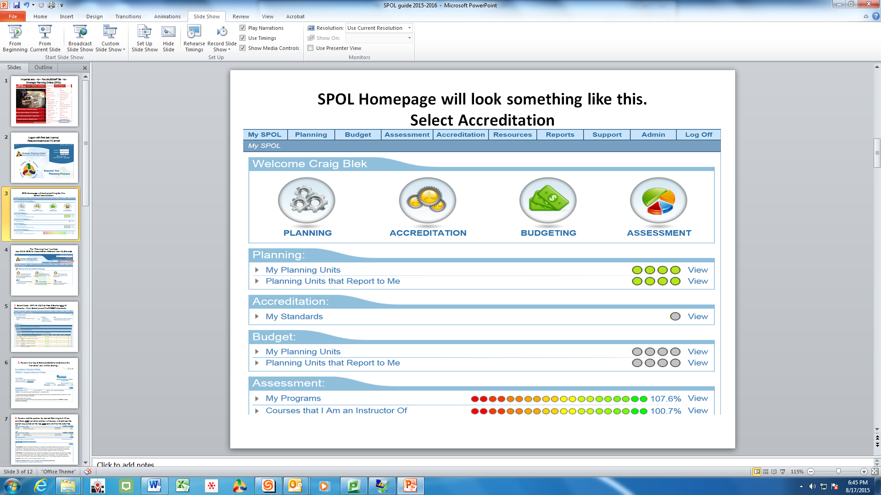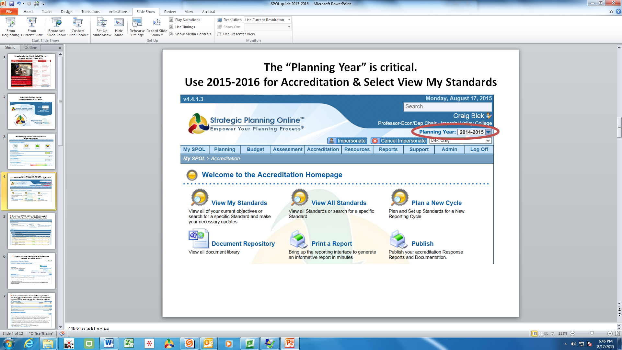

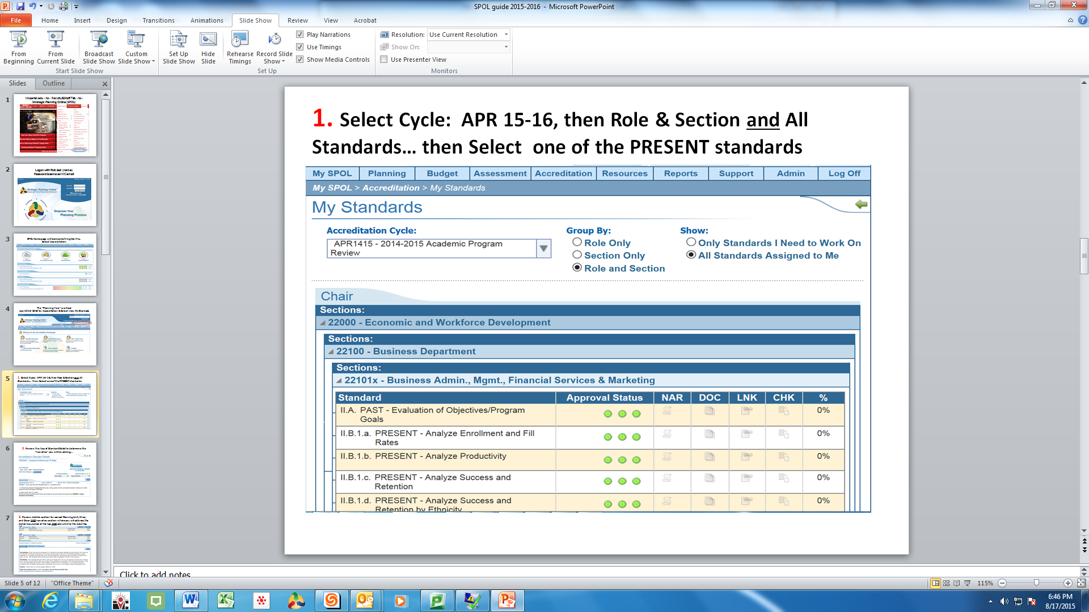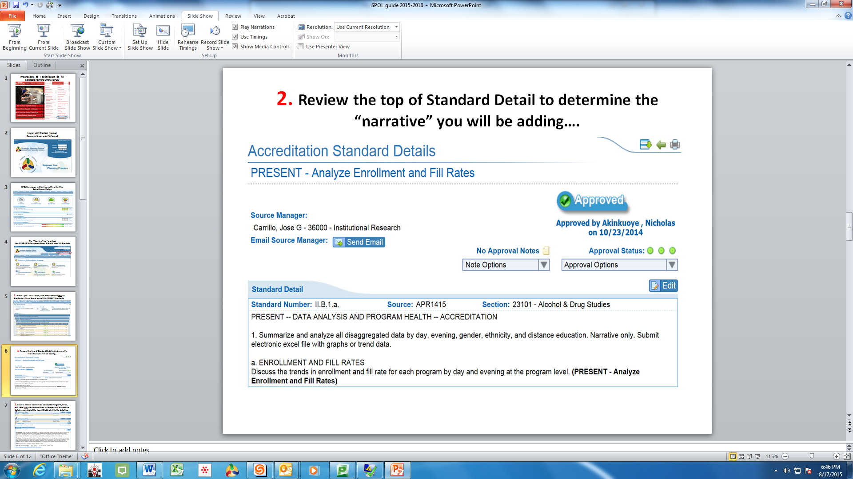

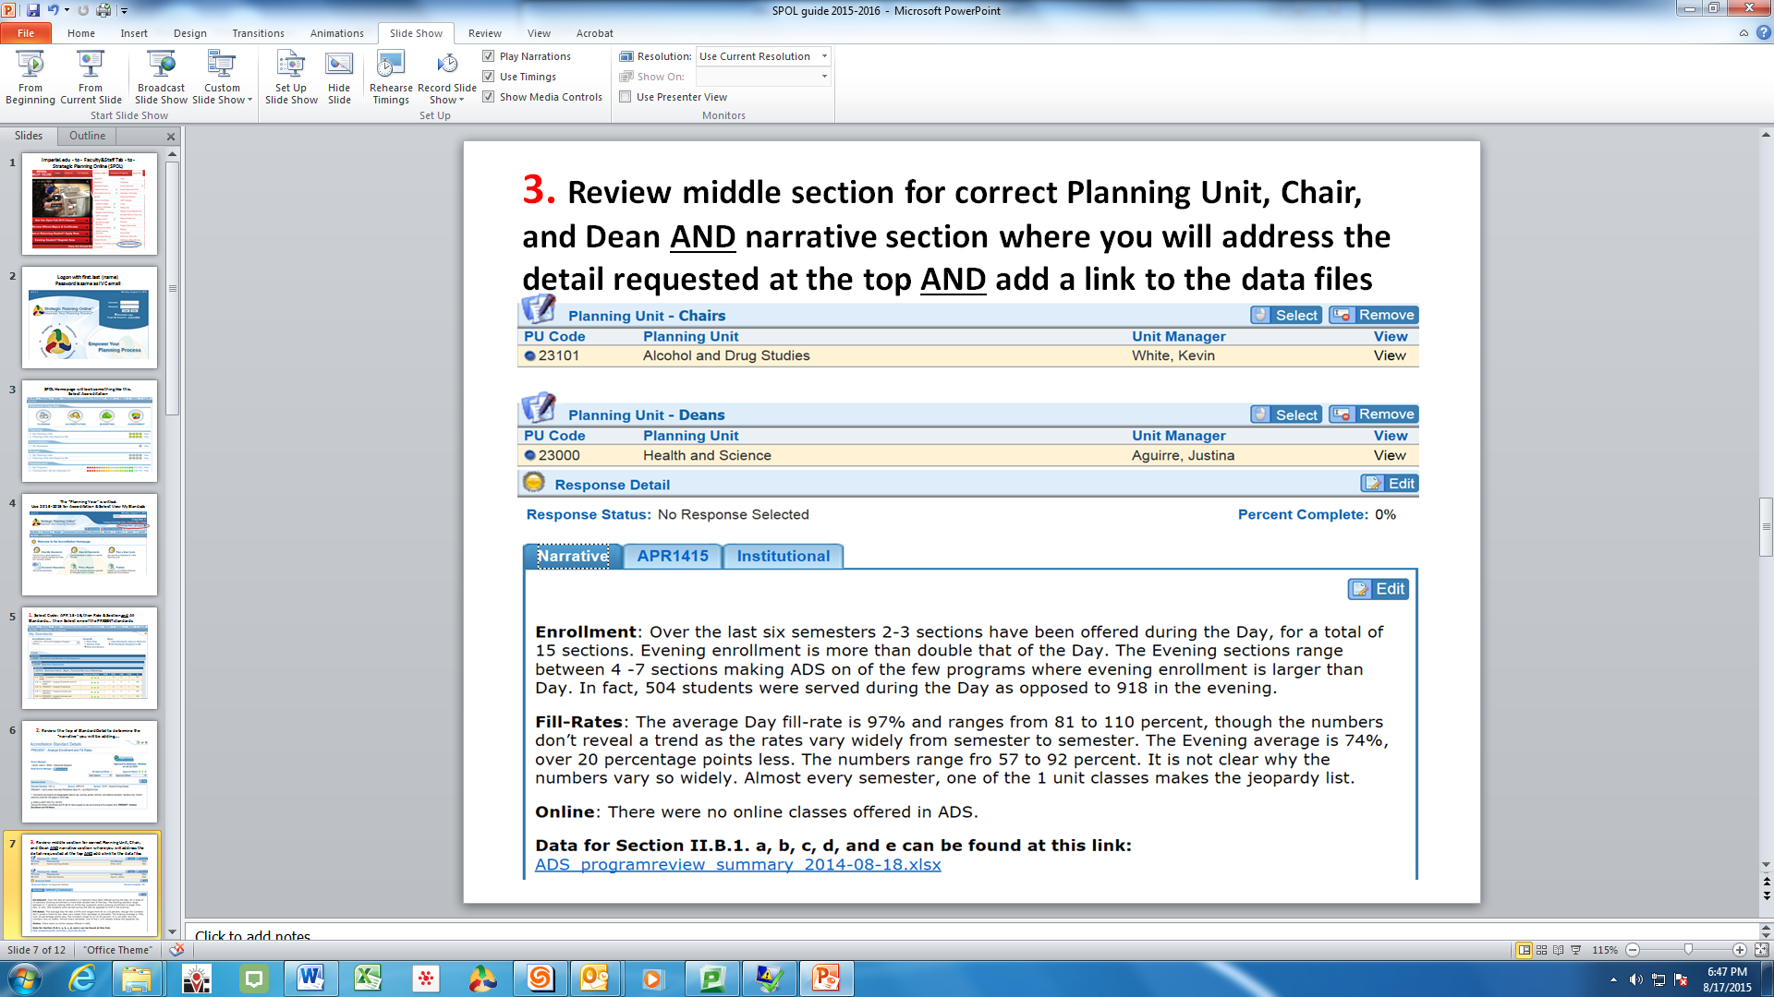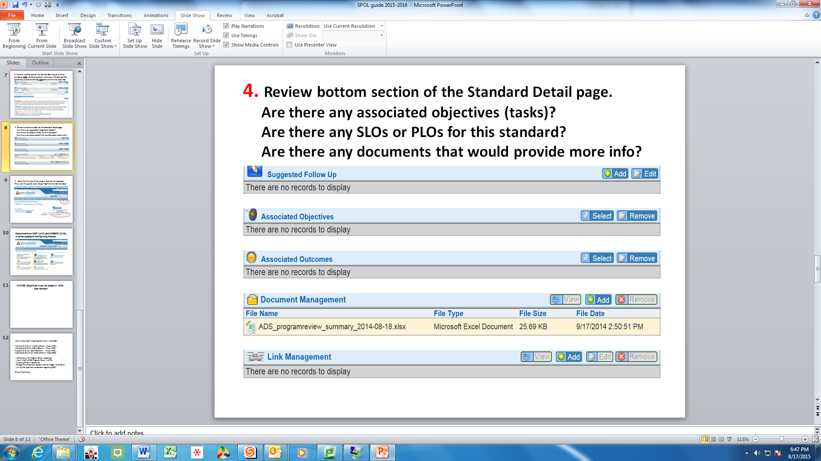

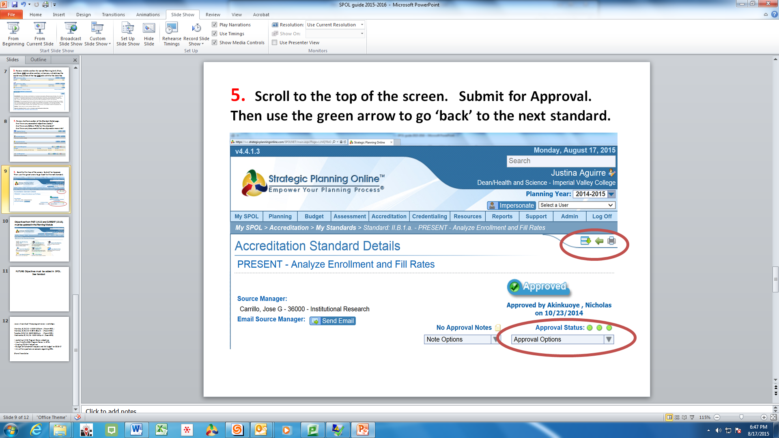

Repeat Steps 1-5 until all Section II.B. Standards are addressed.

Next you will work with the SPOL Planning Module….

Guide to entering status updates for 14-15 and 15-16 objectives in SPOL Planning Module

Select Planning and then select View My Objectives
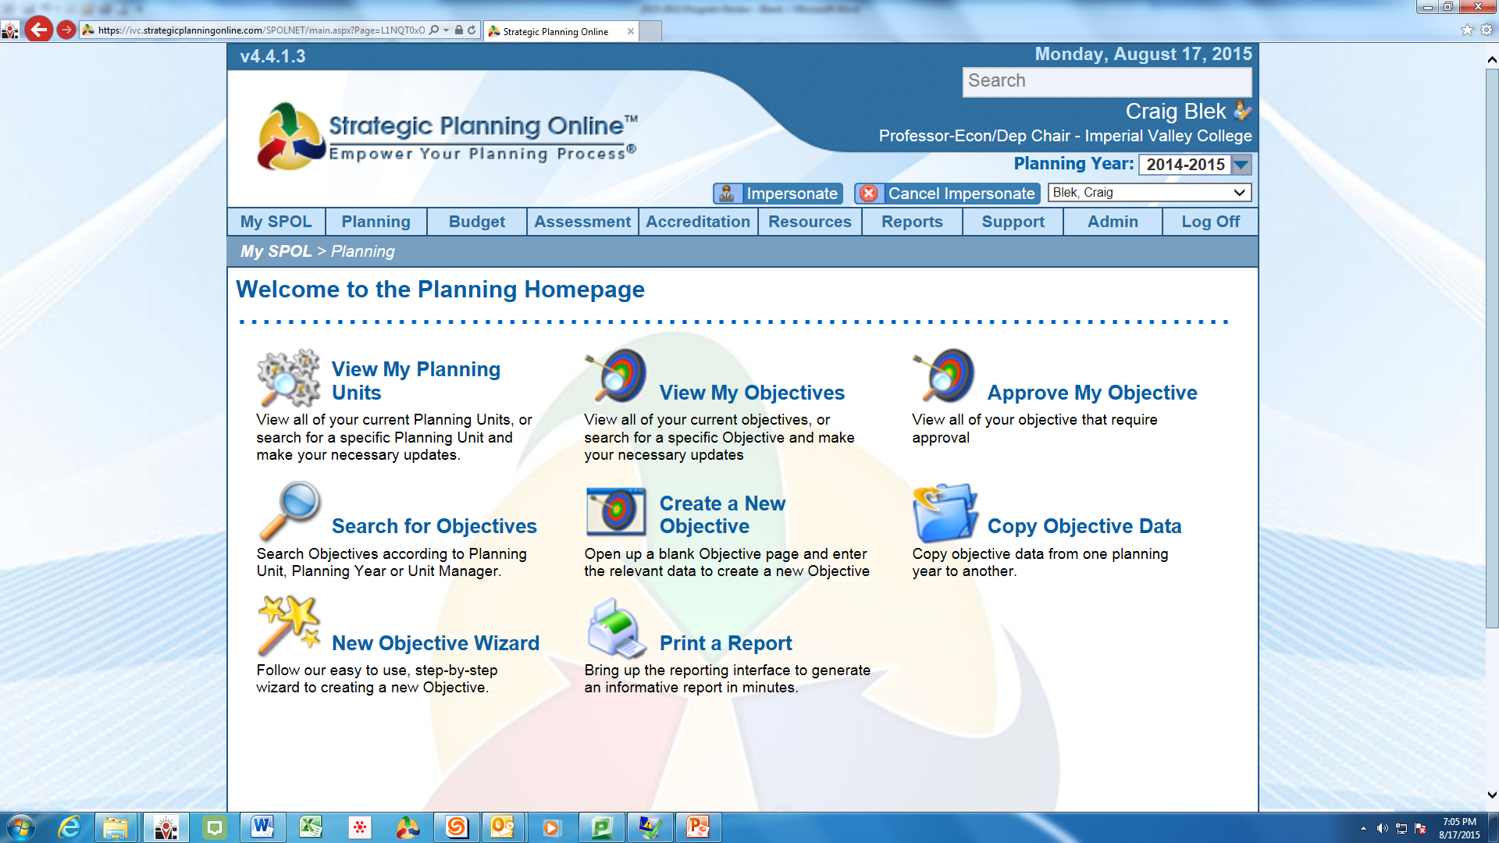

- Begin with 2014-2015 Planning Year (top right hand corner of your screen)
- Select the Program and then the Objective

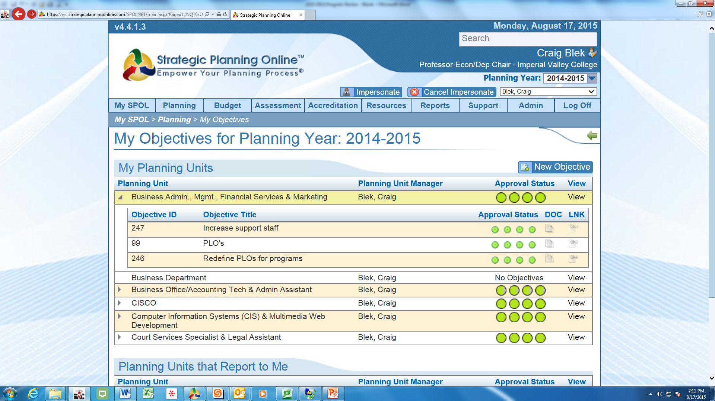

- Review the top of the Objective Detail page to:
  - ensure accuracy
  - update the Objective Descriptor “Status”.
    - Select EDIT
    - Use ‘drop down arrow’ to select appropriate Objective Status
    - SAVE

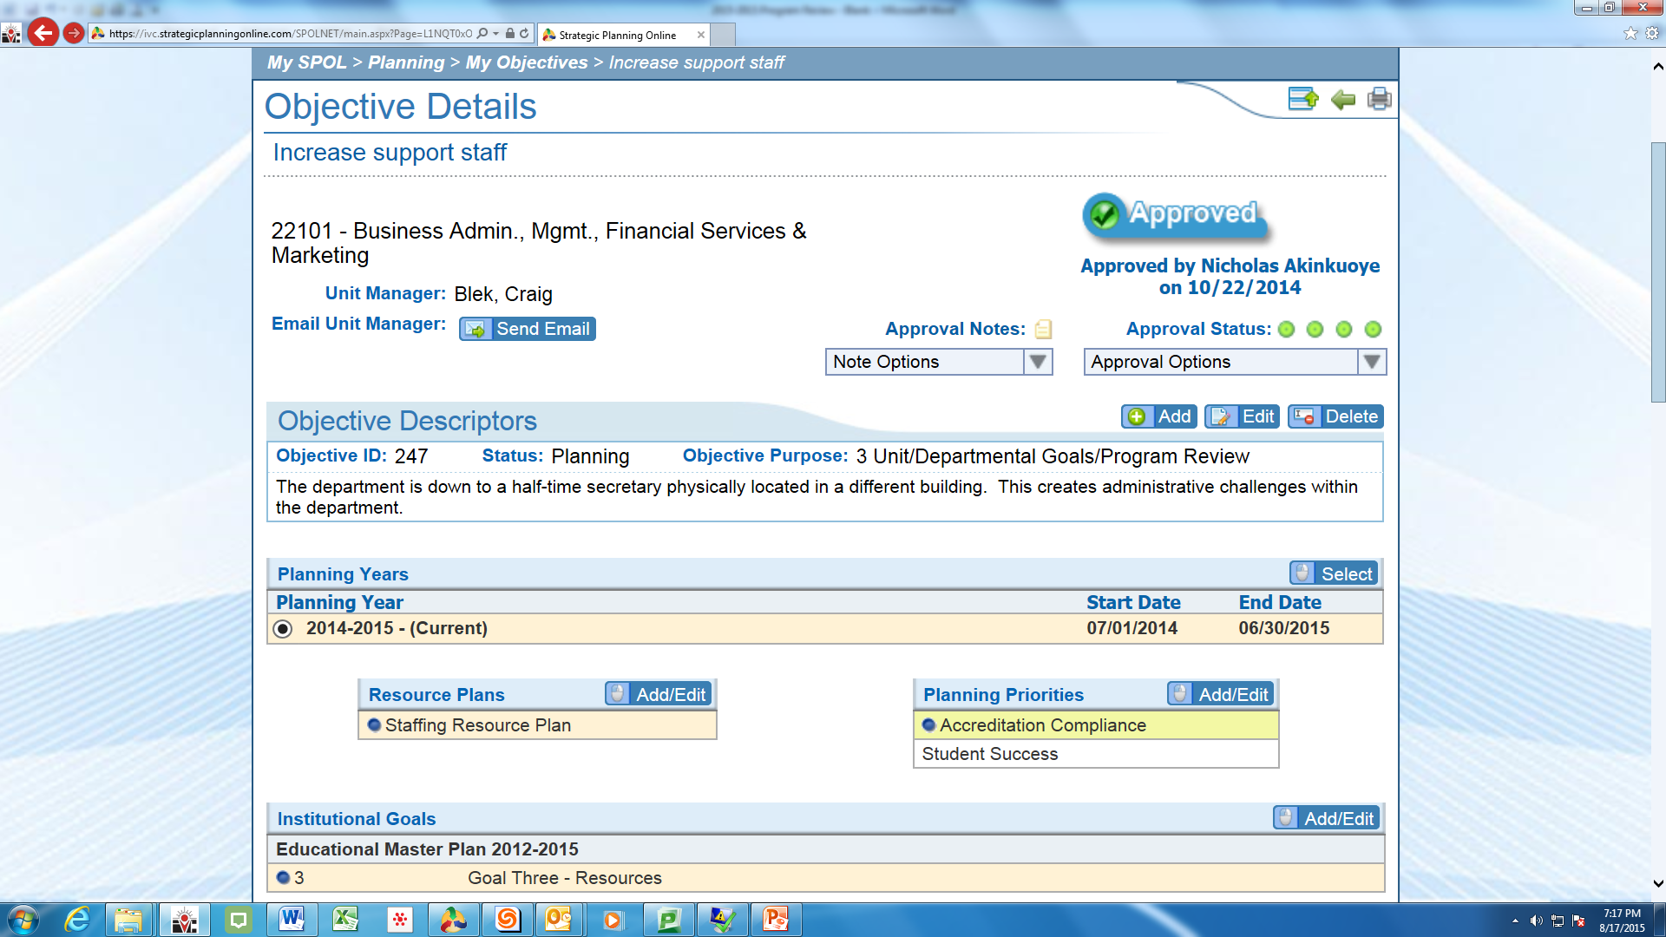

- Scroll to the middle of the Objective Details page
  - Select the first Task and click on EDIT
  - Use the drop down arrow to select ‘Status’ of complete or closed
    - Complete if task fulfilled
    - Closed if task not fulfilled for any reason (lack of funding, time…)
    - Add in ‘Remarks’ the rationale or commentary on success or failure of this task.
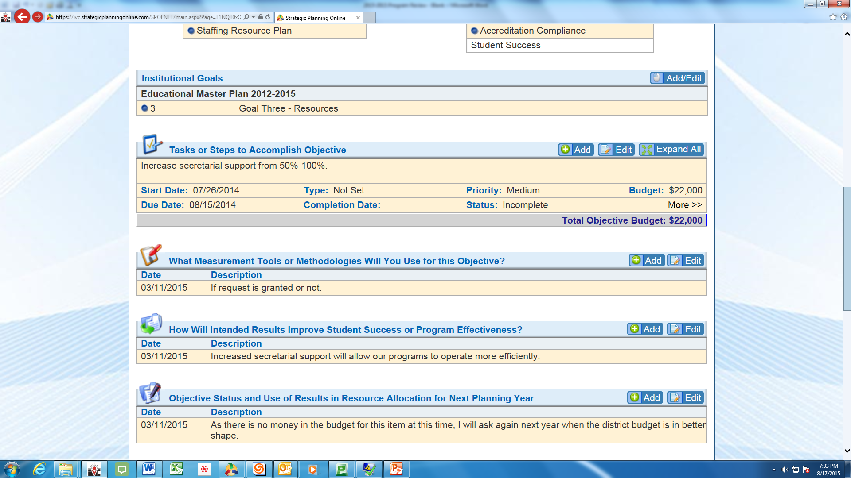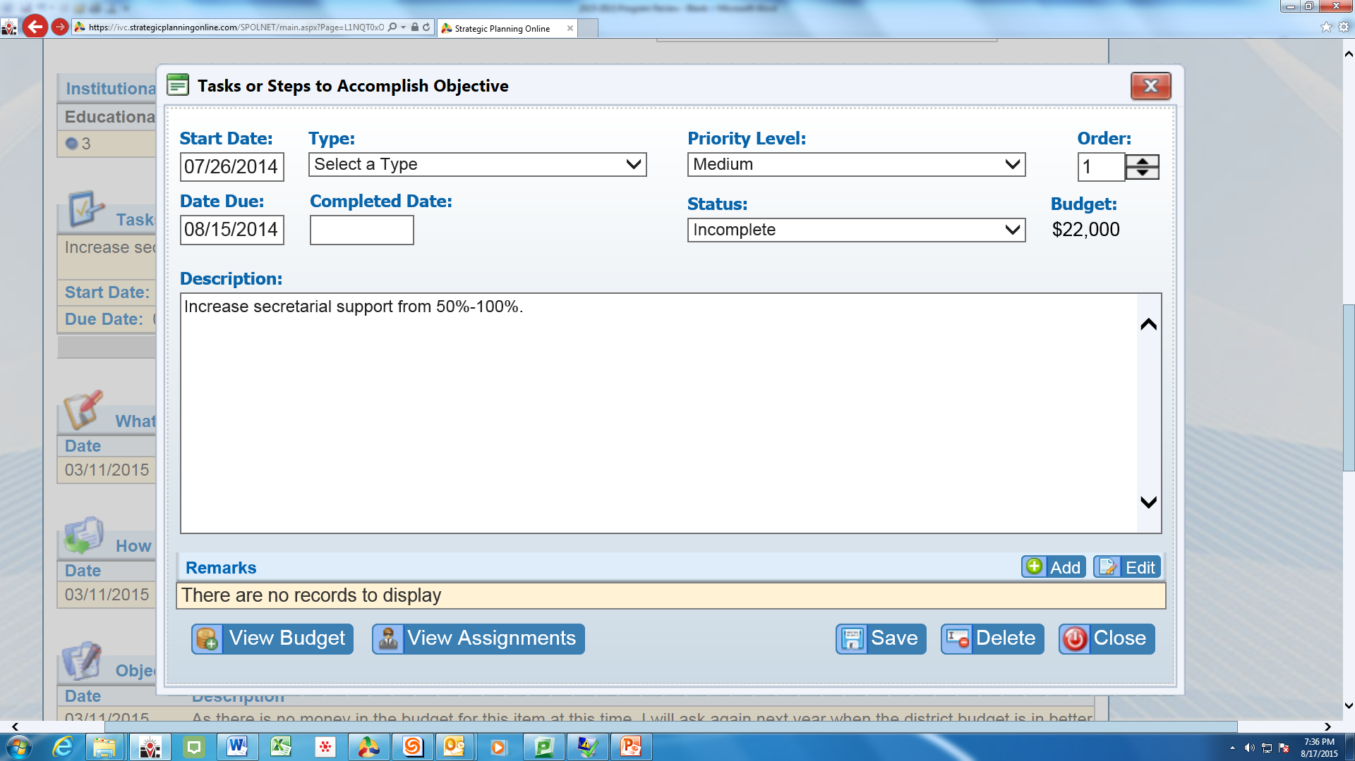

You can also provide a statement on the Objective Status and how it will impact your request for Resource Allocations for the 2016-2017 year

- Scroll to the bottom of the Objective Details page
  - Are there associated Standards ?
  - Are there associated SLOs or PLOs ?
  - Is there a need for supportive documents?
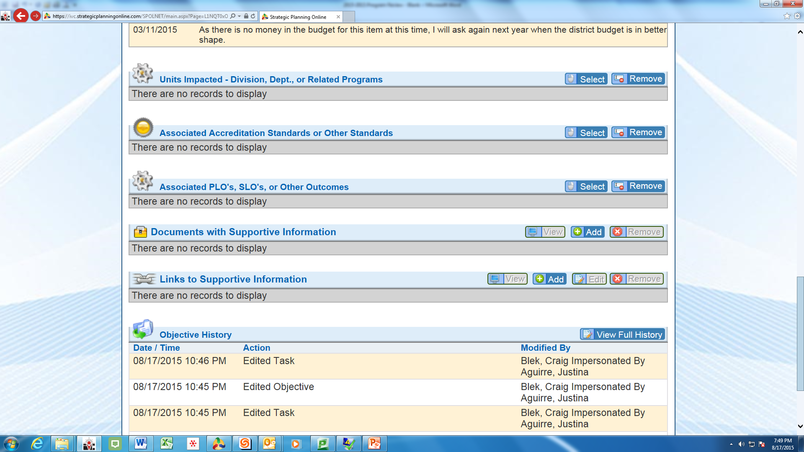

Repeat Steps 1-5 until all Objectives and Tasks for 2014-2015 are addressed.
Same for Planning Year 2015-2016 (change year at the top right corner of the screen)

Next you will develop new Objectives and Tasks for Planning Year 2016- 2017

Guide to entering NEW Objectives for 16-17 in SPOL Planning Module

Select Planning and then select Copy Objective Data or Create a New Objective

- If you have ‘Closed’ objectives from 2014-2015 that are still needed, but were not completed for any reason, you can ‘Copy Objective Data’ forward to 2016-2017 with the following steps.
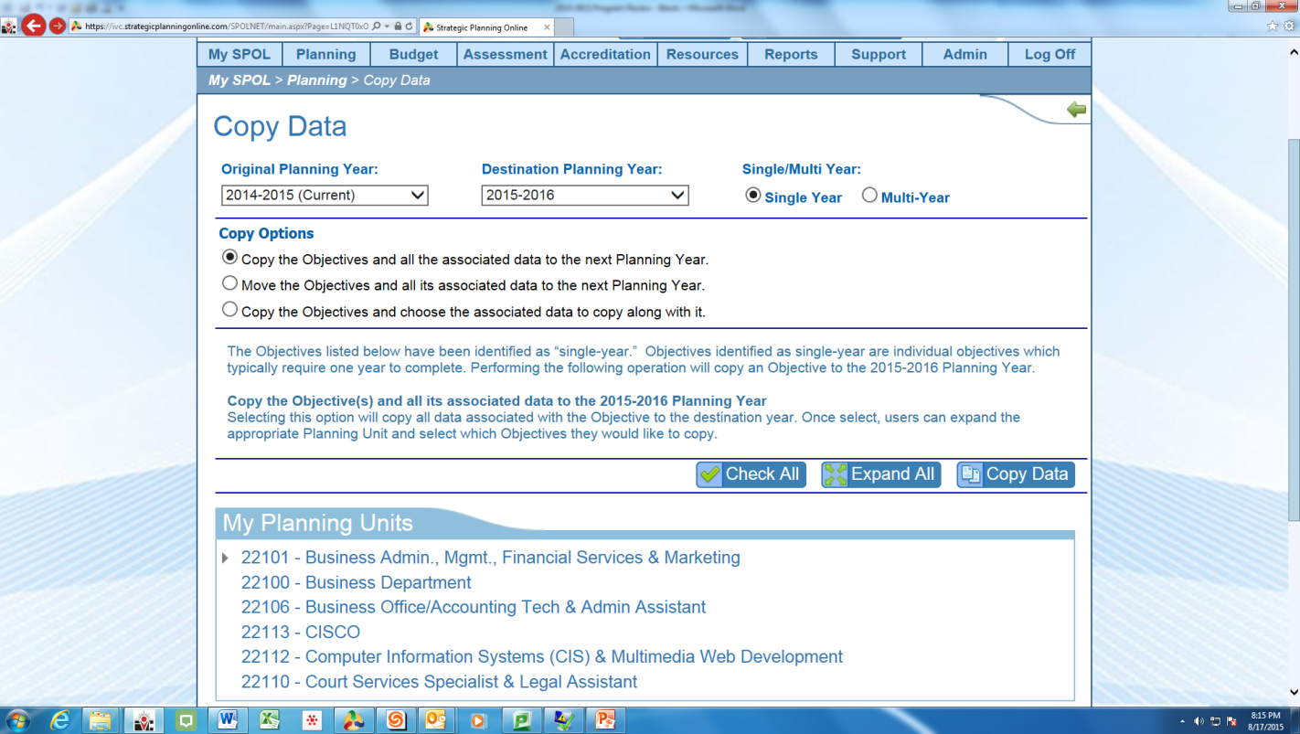

Identify the “Original Planning Year’ for the Objectives
Set the ‘Destination Planning Year’
Select Multi-Year
Copy the Objective and a) all the data or b) choose data
Expand the Planning Units
Check the Objectives to copy forward
Finally, click on ‘Copy Data’

- To Create a New Objective, determine: a) the Objective Title, b) the Planning Unit, c) the Planning Year, d) Objective Purpose, e) Objective Status and then f) provide an Objective Description. SAVE
- Complete all areas on the top of the Objective Details page
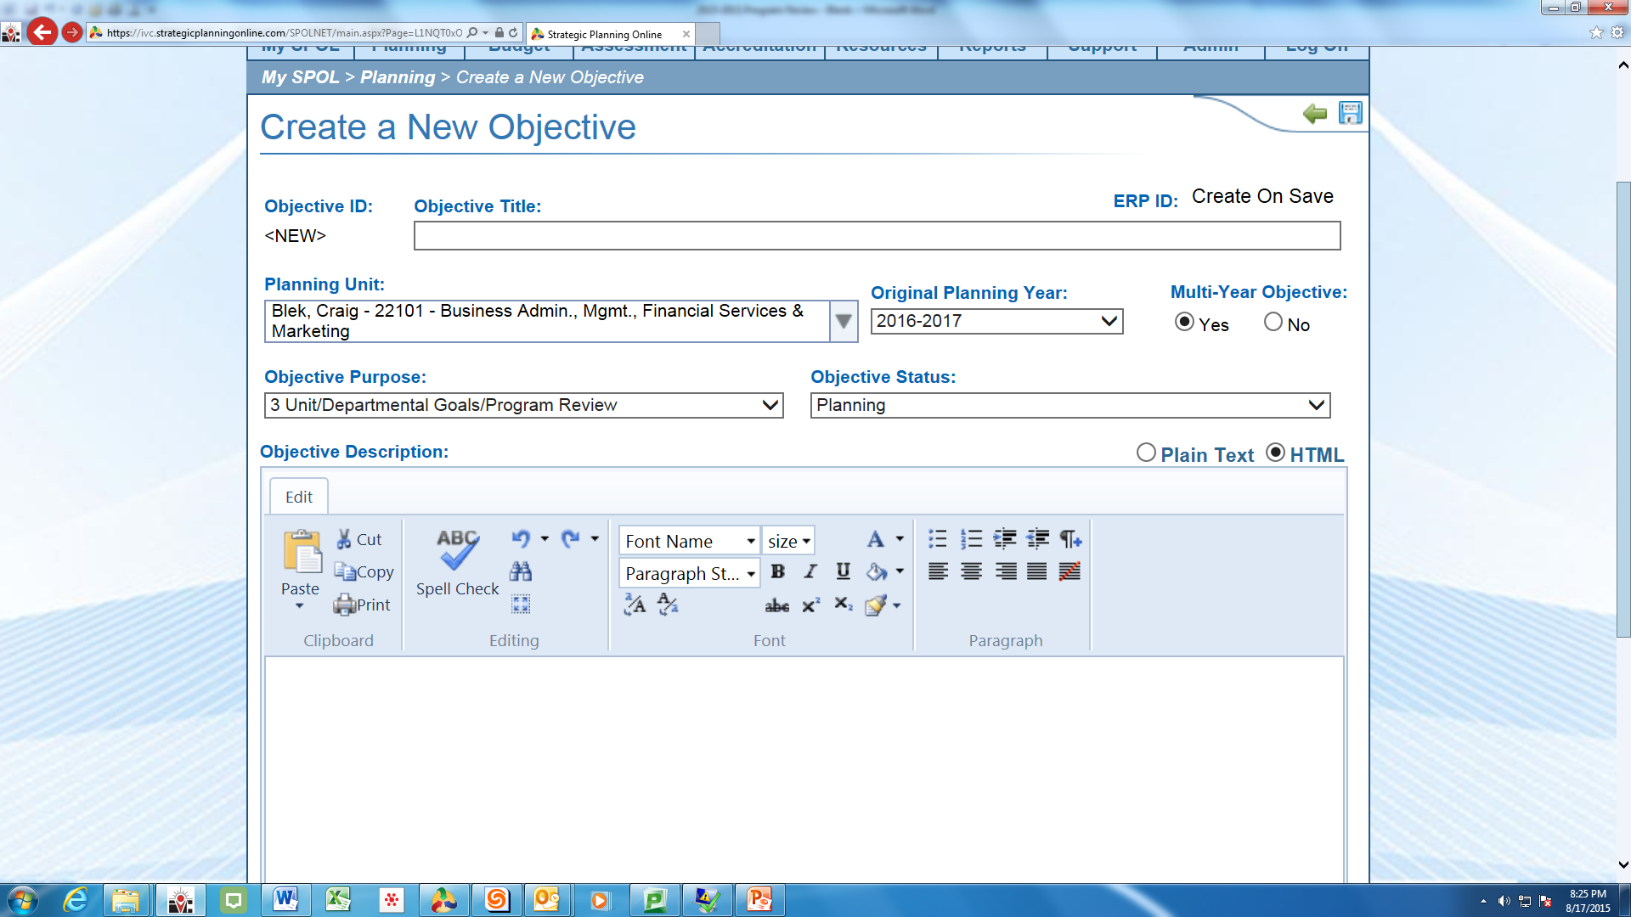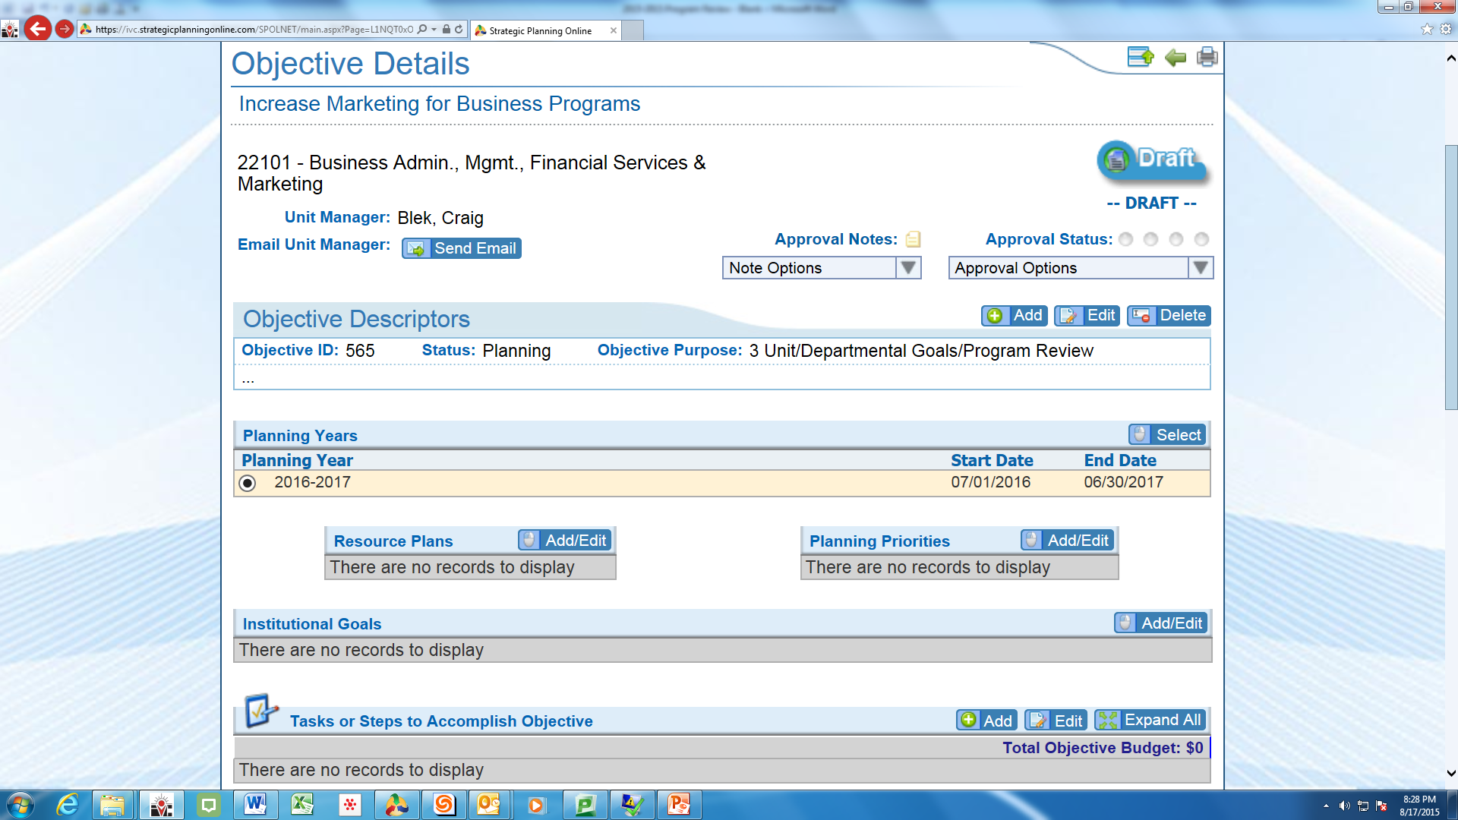

- Complete all the elements of the TASK and the subsequent areas below the TASKs if appropriate
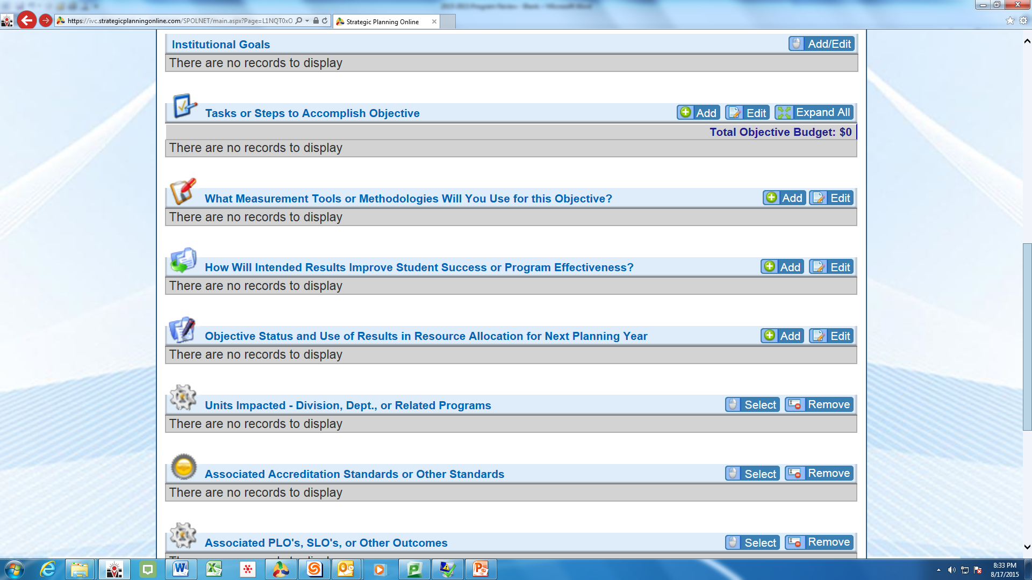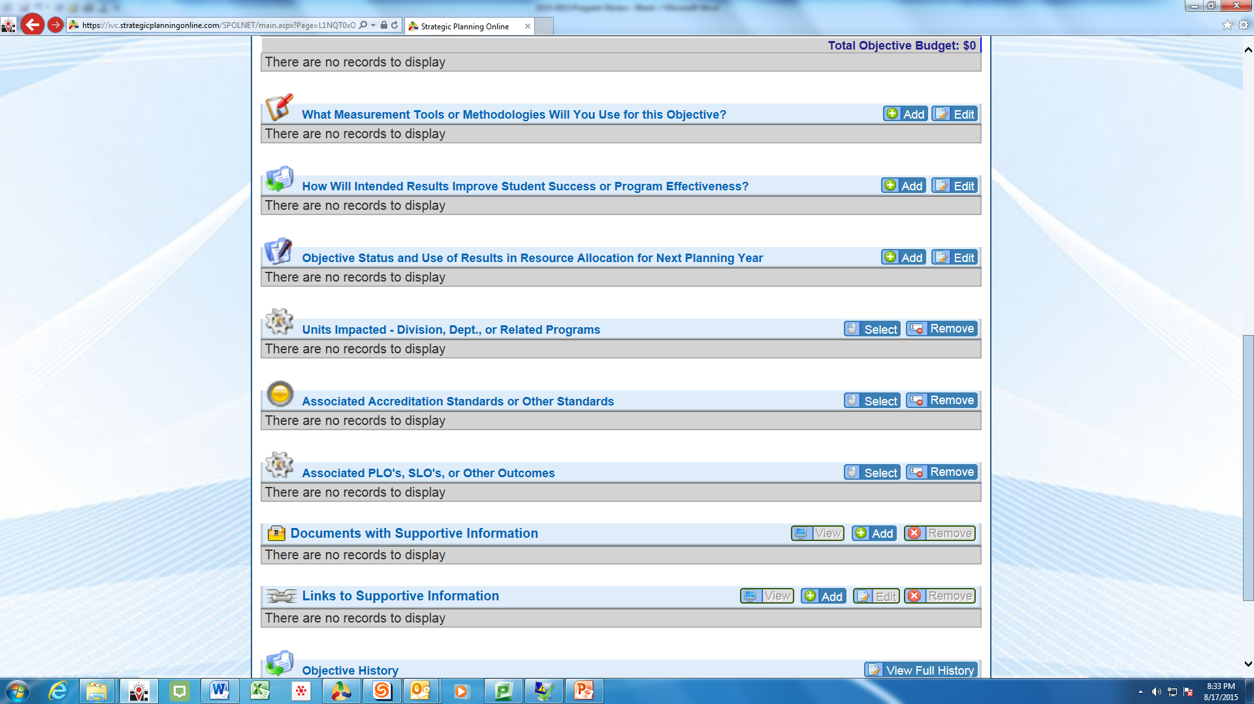

Guideline for considering Professional Development needs in Program Review

Professional Development activities are critical for all staff, faculty, and administrators to ensure ongoing student success, accreditation, currency in programs, personal growth for employees, as well as strengthening camaraderie and moral across the campus community. Therefore, please be sure to include professional development activities in your program reviews with rationales and/or data for any ‘enhanced request’ funding.

SPOL – 6 Step Process
- Create an Objective, which requires

  - Objective purpose
  - Descriptor of objective
  - Is it tied to any specific Unit Goal?
  - Tie it to a Resource Plan – Professional Development
  - Tie it to Planning Priorities – Student Success and/or Accreditation
  - Tie it to Institutional Goal(s) as appropriate

- Create Task(s), which requires

  - Start & Due Dates (estimate)
  - Task Type – Quantitative vs. Qualitative
  - Priority Level – High, Medium, Low
  - Description – should be more detailed than the global objective and can include multiple prof develop activities – just describe them

- Assign responsible parties
  - Chair or discipline designee or who
- Budget estimated or actual costs, which requires:

  - Department Budget Account
  - General Ledger (GL) Code – 1300 faculty salaries other or 2398 classified professional growth
  - Priority Level – High, Medium, Low
  - Commodity Type – Miscellaneous, Salaries,
  - Is it Classroom or Teaching Use
  - Is it a Legal or Contractual Requirement (accreditation)
  - How many units and Price per unit
  - Justification: Here is where you should include the rationale and data if applicable. Think in terms of are these funds a) mandated, b) need to have, c) will improve outcomes, or d) just nice to have. Also if you think there are categorical/grant funds available explain

- How will you measure the success of this task – what tool or methodology will you use to validate the success?

- How will this task improve Student Success or Program Effectiveness or Accreditation

