Academic Program Review



|  |  |  |
| --- | --- | --- |
| **ACADEMIC YEAR** | 2013-2014 | Basic Skills  Transfer  Career Technical Education (CTE) |
| **PROGRAM** | Behavioral Science | |
| **DEPARTMENT** | Behavioral and Social Sciences | |
| **DIVISION** | Health and Sciences | |
| **SUBMITTER** | Kevin White, Department Chair | |

**I. INSTITUTIONAL GOALS**

|  |  |
| --- | --- |
| INSTITUTIONAL GOAL  **1** | **INSTITUTIONAL MISSION AND EFFECTIVENESS** – The College will maintain programs and services that focus on the mission of the College supported by data-driven assessments to measure student learning and student success. |
| INSTITUTIONAL GOAL  **2** | **STUDENT LEARNING PROGRAMS AND SERVICES** – The College will maintain instructional programs and services which support student success and the attainment of student educational goals. |
| INSTITUTIONAL GOAL  **3** | **RESOURCES** – The College will develop and manage human, technological, physical, and financial resources to effectively support the College mission and the campus learning environment. |
| INSTITUTIONAL GOAL  **4** | **LEADERSHIP AND GOVERNANCE** – The Board of Trustees and the Superintendent/President will establish policies that assure the quality, integrity, and effectiveness of student learning programs and services, and the financial stability of the institution. |

**II. PROGRAM GOALS**

1. **PAST – EVALUATION OF PREVIOUS CYCLE OBJECTIVES/PROGRAM GOALS (SET IN PREVIOUS YEAR)**

List your previous objectives/goals and associated Institutional Goals. All program goals must address at least one of the institutional goals.

|  |  |  |  |  |  |
| --- | --- | --- | --- | --- | --- |
| **PAST PROGRAM GOALS**  (Describe past program goals.) | | | | | **INSTITUTIONAL**  **GOAL(S)**  (Check all that apply.) |
|  | |  | | |  |
| **1** | **PAST PROGRAM GOAL #1** | | | | **INSTITUTIONAL GOAL(S)** |
| **Identify Program Goal from Last Program Review:** A more stable faculty (particularly in Anthropology). | | | | 1  2  3  4 |
| Met | | Partially Met | Not Met |
| **Provide detail on any improvements/effectiveness and detail status on those not fully met:** This goal has only been partially met because there has been significant faculty turnover in many of the disciplines that constitute this major, especially in Psychology and Sociology. We have added some new part-time faculty to offset the losses. | | | |
|  |  | | | |  |

|  |  |  |  |  |
| --- | --- | --- | --- | --- |
| **2** | **PAST PROGRAM GOAL #2** | | | **INSTITUTIONAL GOAL(S)** |
| **Identify Program Goal from Last Program Review:**  More strategic use of online offerings, especially given the reorganization of the Distance Education protocols. | | | 1  2  3  4 |
| Met | Partially Met | Not Met |
| **Provide detail on any improvements/effectiveness and detail status on those not fully met:** The College emerged from the moratorium on Distance Education (DE) with a new DE Director and a restructured, more vigorous online program. Faculty was encouraged to create or recreate “core” offerings in the various disciplines to augment the F2F classes thereby offering students greater access with this alternative delivery option. We currently have over 6 classes under construction. | | |
|  |  | | |  |
| **3** | **PAST PROGRAM GOAL #3** | | | **INSTITUTIONAL GOAL(S)** |
| **Identify Program Goal from Last Program Review:**  Expansion of the Behavioral and Social Sciences (BSS) Media Library to provide all disciplines with the major with current state-of-the-art media resources to supplement instruction. | | | 1  2  3  4 |
| Met | Partially Met | Not Met |
| **Provide detail on any improvements/effectiveness and detail status on those not fully met:** | | |

**Comments**: Maintaining a stable and adequate faculty pool remains a constant challenge for our institution given its location, yet we are always looking for ways to expand it. It is a disservice to students to cancel needed classes because we cannot secure the required staff. The Media Library expanded significantly since the last review as the Department purchased over $8,000 worth of media resources including hundreds of new videos and a software program for inventory and tracking purposes.

1. **PRESENT – DATA ANALYSIS AND PROGRAM HEALTH**
2. Summarize and analyze all disaggregated data by day, evening, gender, ethnicity, and distance education regarding enrollments, fill rates, productivity, completion, success, retention, persistence, and transfer (complete a, b, & c). ***Attach graphs or trend data***.
3. Discuss and chart the trends in enrollment and fill rate for each program by day and evening at the program level.

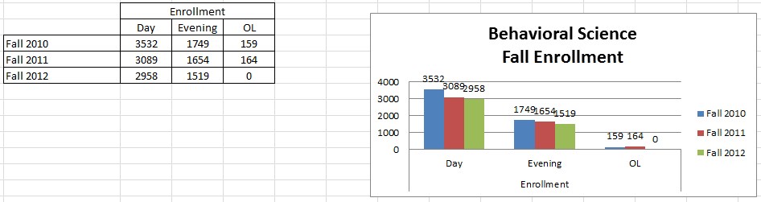

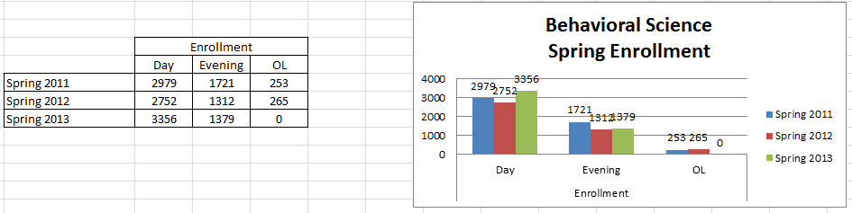

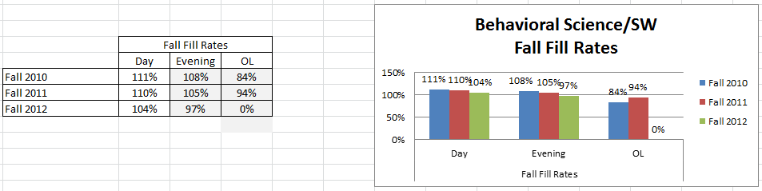

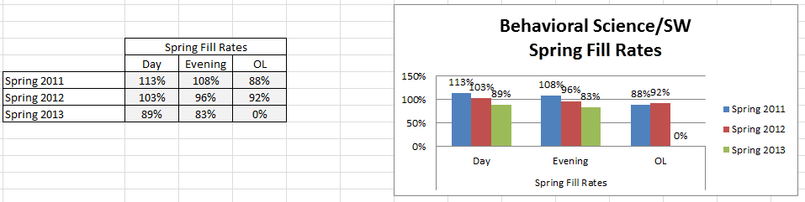

**Comments**: **Day Enrollment** saw a decline in each semester over the period analyzed (from 3532 to 2958). **Evening Enrollment** also experienced a decline but it was not as dramatic (from 1749 to 1519). **Online** figures changed only slightly before the moratorium. In a reverse of the trend for Day and Evening, online enrollments were higher in the Spring semesters than in the Fall. The numbers indicate that enrollments have slowed but are stabilizing.

**Fill rates** for Fall Day and evening classes dipped slightly from superior numbers to strong. All but one semester was above 100 percent, except for Fall of 2012 which fell to 97% (111% the highest). Despite the drop in enrollment fill rates remain remarkably high.   
Spring Day and Evening fill rates dropped more significantly from a high of 113% down to 83%. Spring 2013 saw both Day and Evening rates register 89% and 83% respectively. The rates have stabilized. Of the six Day and Evening percentages, three were above 100% (113, 108, and 83) and three were below (96, 89, and 83 percent’s).

1. What are the trends in productivity? (WSCH/FTEF) The goal is 525 as per state guidelines. A low number means that we are below target levels for productivity. For example, in a small class that has a mandated cap of 15 students, the fill rate may be 100% but the productivity number (WSCH/FTEF) will be very low. A class with a cap of 40 students with a 100% fill rate will have a productivity number close to or above 525.

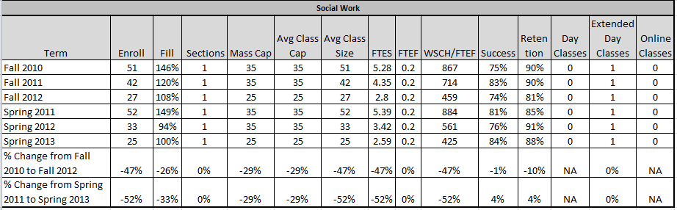

**Comments**: Productivity dropped tremendously over the period, from a high 867 to 425. Though Spring 2011 jumped back to 884, the overall percent of change in Fall was -47 and -52 for Spring. This is a troubling trend. Many factors account for this including the drop in enrollment; enrollment management; the closure of the external campuses; and challenges with maintaining an adequate faculty pool. In some of these disciplines full-time faculty are carrying near double loads. As new classroom space becomes available and the student population grows, the numbers should improve.

1. Discuss and chart the success and retention rates by day, evening (extended day), and online classes in each program and identify gaps.

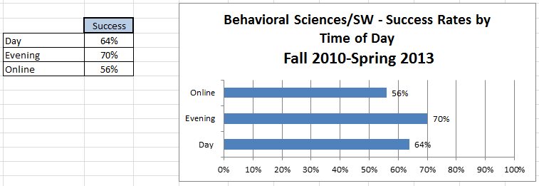

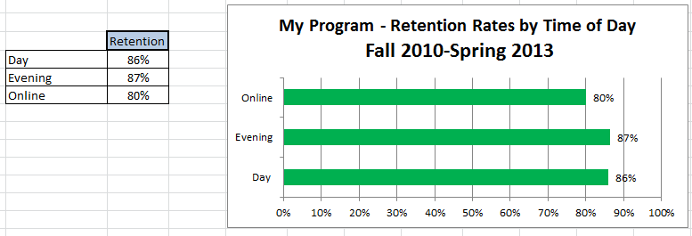

Success and retention show the same trend though the numbers differ. Evening class continue to have the highest success and retention followed by Day and then online. Online classes were not as numerous so the percentages may be skewed. Retention remains high as Day, Evening, and Online registered in the 80 percentiles.

1. Discuss and chart the success and retention rates in each program and identify gaps for five ethnic groups. (African-American, White, all Hispanics, Other, Unknown).

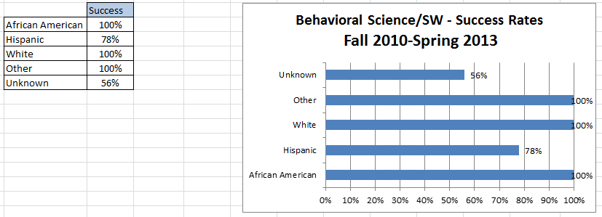

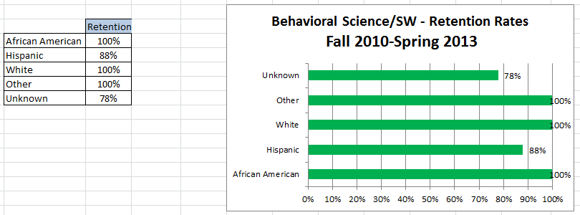

**Comments**: The data for these are skewed by the low numbers of African American and Other students. But the trends remain consistent throughout the disciplines with White and Unknown the highest followed in most cases by Hispanic and then African American. The Unknown category has high numbers, second only to White, yet the make-up this category is nebulous. It’s difficult to assess the needs of the unknown if they remain outside of any category.

1. Discuss the trends in the number of degrees or certificates awarded, if applicable. (You may be able to expand more about this in B.3 below.)

|  |  |  |  |  |  |  |
| --- | --- | --- | --- | --- | --- | --- |
| **Program Completion** |  |  |  |  |  |  |
| **Number of Degrees and Certificates Awarded 2010-2011 through 2012-2013 (3 years)** | | | | | | |
|  |  |  |  |  |  |  |
| **Degrees** | **Awarded** |  | **Certificates** | | | **Awarded** |
| A.A. Behavioral Sciences | 107 |  | N/A | | | N/A |
|  |  |  |  |  |  |  |

The number of degrees awarded increased from 73 in last Program Review to 107. This is a roughly a 22 percent jump, which indicates the program is growing and is more demand among students.

1. What program changes, if any, will you recommend that you expect would have a positive effect on your students in your program, if applicable?

**Comments**: More online classes, more streamlined ADTs, more classroom space that allows for a more balanced distribution of class offerings over the course of a day will definitely have a positive effect on student learning and success.

1. Summarize revisions, additions, deletions, or alternate delivery methods to courses and/or program based on the last program review.

**Comments**: As more Online classes come back on line and more class space is created (new buildings and remodels) it will facilitate more efficient block scheduling. The implementation of the new transfer degrees continues to streamline the time and units needed for students to matriculate. Deactivating and deleting programs that no longer serve the mission or discipline will continue. Increasing the use of Blackboard and adding more relevant, cutting edge media resources has sharpened the delivery of services to students and facilitates greater student success.

1. Evaluate the program’s viability by addressing program completion, size (FTES), projections (growing/stable/declining), and quality of outcomes. For CTE programs, also include labor market projections, placement, and performance on external testing/exams (i.e. ASE, NABCEP) and industry-recognized credentials, placement, and performance on external testing or exams (NCLEX, ASC, NAP).

**Comments**: The program remains stable but growing. There are areas of concern as well as areas of improvement. The 22% increase in degrees awarded is very positive. The Distance Education part of programing is also improving with a more rigorous foundation and the development of some of our “core” courses into an online format. The Media Library is providing instructors with more engaging media for students and provides a resource for the whole campus.

Success and retention rates have remained fairly stable from the last review. Enrollment and fill rates dropped over the period but the degree of change has slowed and shows signs of stabilization. One major concern going forward is the drop in productivity. From a high of 867 in Fall 2010, productivity dropped steadily and Spring 2013 was the only semester to drop below the 525 benchmark to 425. Another troubling issue is the categorization of students. The Unknown category is huge, rivaling the majority status of White which makes it difficult to address because they remain unknown. And, finally the sheer number of disciplines involved in this major makes it somewhat difficult to average percentages and renders the analysis less precise.

**C. FUTURE – LIST OF “SMART” (SPECIFIC** **MEASURABLE ATTAINABLE RELEVANT** **TIME-LIMITED) PROGRAM OBJECTIVES FOR NEXT ACADEMIC YEAR TO ADDRESS PROGRAM IMPROVEMENT, GROWTH, OR UNMET NEEDS/GOALS. ALL PROGRAM GOALS MUST ADDRESS AT LEAST ONE OF THE INSTITUTIONAL GOALS.**

|  |  |  |  |  |  |
| --- | --- | --- | --- | --- | --- |
| **FUTURE PROGRAM GOALS**  (Describe future program goals. List in order of budget priority.) | | | | | **INSTITUTIONAL GOAL(S)**  (Check all that apply.) |
|  | | | | |  |
| **1** | **FUTURE PROGRAM GOAL #1**  Budget Priority #1 | | | | **INSTITUTIONAL GOAL(S)** |
| **Identify Goal:** Offer more “core” Psychology online courses. | | | | | 1  2  3  4 |
| **Objective:** Provide alternative course delivery methods that accommodate student needs. | | | | |
| **Task(s):** Complete and activate Psychology 101, 104, and 204 online courses. | | | | |
| **Timeline:** Academic year 2014-2015 | | | | |
| **EXPENSE TYPE** | | **FUNDING TYPE** | | **RESOURCE PLAN**  (Check all that apply.) | **BUDGET REQUEST** |
| One-Time  Recurring | | Categorical  Specify: | General Fund | Facilities  Marketing  Technology  Professional Development  Staffing | $0 |
|  | | | | |  |

|  |  |  |  |  |  |
| --- | --- | --- | --- | --- | --- |
| **2** | **FUTURE PROGRAM GOAL #2**  Budget Priority #2 | | | | **INSTITUTIONAL GOAL(S)** |
| **Identify Goal:** Expand utilization of Media Library | | | | | 1  2  3  4 |
| **Objective:** Provide relevant, cutting edge media to faculty for instruction. | | | | |
| **Task(s):** Organize, label, inventory, and track media usage using a new software program purchased last academic year. | | | | |
| **Timeline:** Academic year 2013-2014 | | | | |
| **EXPENSE TYPE** | | **FUNDING TYPE** | | **RESOURCE PLAN**  (Check all that apply.) | **BUDGET REQUEST** |
| One-Time  Recurring | | Categorical  Specify: | General Fund | Facilities  Marketing  Technology  Professional Development  Staffing | $0 |

|  |  |  |  |  |  |
| --- | --- | --- | --- | --- | --- |
| **3** | **FUTURE PROGRAM GOAL #3**  Budget Priority #3 | | | | **INSTITUTIONAL GOAL(S)** |
| **Identify Goal:** Secure an adequate pool of part-time faculty. | | | | | 1  2  3  4 |
| **Objective:** Expand the pool of part-time faculty in key disciplines of the major. | | | | |
| **Task(s):** Focus on recruiting online instructors outside of IVC. | | | | |
| **Timeline:** Academic year 2013-2014 | | | | |
| **EXPENSE TYPE** | | **FUNDING TYPE** | | **RESOURCE PLAN**  (Check all that apply.) | **BUDGET REQUEST** |
| One-Time  Recurring | | Categorical  Specify: | General Fund | Facilities  Marketing  Technology  Professional Development  Staffing | $0 |
|  | | | | |  |
| **TOTAL BUDGET REQUEST** | | | | | $0 |

1. How will your enhanced budget request improve student success?

Comments: None of these requests require additional funding. However, these are Department issues that will improve the delivery of services and provide greater resources for Department faculty and the students served. Expanding the pool of faculty continues to be a perennial challenge yet one that is vital for the success of this program and for facilitating continuous program improvements.

**III. INSTITUTIONAL STUDENT LEARNING OUTCOMES (ISLOs)**

|  |  |
| --- | --- |
| **ISLO 1** | COMMUNICATION SKILLS |
| **ISLO 2** | CRITICAL THINKING SKILLS |
| **ISLO 3** | PERSONAL RESPONSIBILITY |
| **ISLO 4** | INFORMATION LITERACY |
| **ISLO 5** | GLOBAL AWARENESS |

**IV. PROGRAM LEARNING OUTCOMES (PLOs)**

|  |  |  |  |  |
| --- | --- | --- | --- | --- |
| **PROGRAM LEARNING OUTCOMES**  (Describe learning outcomes.) | | | | **ISLO(S)**  [Link PLO to  appropriate ISLO(s).] |
|  |  | | |  |
| **PLO**  **1** | **PROGRAM LEARNING OUTCOME #1** | | | **ISLO(S)** |
| **Identify Program Outcome:**  Use critical thinking skills regarding the diversity of individuals and groups within the role or culture, ethnic, and economic factors when describing behaviors, attitudes and feelings of people in society. | | | ISLO 1  ISLO 2  ISLO 3  ISLO 4  ISLO 5 |
| **Measurable Outcome Summary:** | | |
| Met | Partially Met | Not Met |
| **Provide detail on any improvements/effectiveness and detail status on those not fully met:** | | |
|  |  | | |  |

|  |  |  |  |  |
| --- | --- | --- | --- | --- |
| **PLO**  **2** | **PROGRAM LEARNING OUTCOME #2** | | | **ISLO(S)** |
| **Identify Program Outcome:**  Apply critical thinking skills to explain how anthropology, psychology, and sociology influence one another as well as individuals and groups in society. | | | ISLO 1  ISLO 2  ISLO 3  ISLO 4  ISLO 5 |
| **Measurable Outcome Summary:** | | |
| Met | Partially Met | Not Met |
| **Provide detail on any improvements/effectiveness and detail status on those not fully met:** | | |
|  |  | | |  |
| **PLO**  **3** | **PROGRAM LEARNING OUTCOME #3** | | | **ISLO(S)** |
| **Identify Program Outcome:**  Apply the scientific method to investigate, interpret, and discuss Behavioral Science issues and social problems. | | | ISLO 1  ISLO 2  ISLO 3  ISLO 4  ISLO 5 |
| **Measurable Outcome Summary:** | | |
| Met | Partially Met | Not Met |
| **Provide detail on any improvements/effectiveness and detail status on those not fully met:** | | |
|  |  | | |  |
| **\*\*\*\*\* ATTACH PLO/SLO GRID \*\*\*\*\*** | | | | |